

**THE UNIVERSITY OF BRITISH COLUMBIA OKANAGAN CAMPUS**

FACULTY OF APPLIED SCIENCE, SCHOOL OF ENGINEERING

**ENGR 406 - Microelectromechanical Systems**

**Final Project Report**

**Lab Group 4**

**Team Members:**

Ali Shafqat Karim

Satvir Johal

Agam Aneja

Khubaib Hashmi

Dec 7, 2022

**Table of Content**

**Introduction** **3**

**Background/Theory** **4**

**Initial Design** **5**

SOLIDWORKS Simulation Setup - Phase 1 8

Simulation Results - Phase 1 10

Layouts - Phase 1 11

Test Plan - Phase 1 14

Results - Phase 1 15

**Final Designs** **16**

Solidworks Simulations - Phase 2 17

Layouts - Phase 2 19

**Test Plan - Phase 2** **21**

**Conclusion** **22**

**References** **24**

**Appendix A** **25**

**Appendix B** **29**

# 

# Introduction

Microelectromechanical Systems, also known as MEMS, are a subfield of microfabrication that involves development using both electrical and mechanical components. These devices, which are typically measured in micrometers or even nanometers, have a wide range of applications, some of which include consumer electronics, automotive systems, medical technology, and aerospace engineering.

In this report, we will examine the principles and processes involved in the design, fabrication and testing of a Lifted Tsang Suspension Assembly, including microfabrication techniques, materials selection/layering, testing and redesigning based on initial learnings. The initial design of this device was inspired from the research paper “Simulation of a Micro-Scale Out-of-plane Compliant Mechanism”(1). In this article, the term out-of-plane refers to the Tsang mechanisms which operate in a direction that is perpendicular to the plane of the device they are attached to. This allows them to move or actuate in a direction that is not possible with traditional, in-plane mechanisms. The goal of this project is to illustrate the application of Tsang Suspensions in technologies that benefit from thermal and electrical isolation from the substrate. This allows them to operate at a greater efficiency and higher sensitivity, such applications are commonly seen in Gyroscopes, Antenas and Accelerometers. Tsang Suspensions can isolate these technologies from the substrate by becoming a free-standing structure after being mechanically assembled or being rotated out of frame.

The design and layout of these MEMS devices was created and analyzed using Solidworks and Klayout simulation softwares. Using Solidworks, the geometry and material properties of the mechanism are input into the software, along with any external loads or forces that may act on it. The simulation then solves complex equations to predict the behavior of the mechanism, including its deflection, stress, and strain. Klayout is used to study layout patterns for lithography of the Tsang suspension devices. These studies were conducted to better analyze, redesign and improve performance of this device. Overall, this report aims to provide a comprehensive overview of the design and testing of such MEMS devices and to further learn the capability of this technology.

# Background/Theory

The material that we used for the project was SU8. SU8 is a type of photolithography material used in the fabrication of microelectromechanical systems (MEMS) and other microscale devices. It is a highly viscous epoxy-based polymer that is capable of achieving high resolution and feature sizes down to 1 micron.

One advantage of SU8 is its high mechanical strength and durability, making it suitable for use in applications where devices need to withstand extreme temperatures and harsh environments. Additionally, SU8 has a low coefficient of thermal expansion, which helps to maintain the integrity of structures during temperature changes.

However, SU8 also has some disadvantages. One major challenge is the material's long curing time, which can lead to long fabrication processes and high costs. Additionally, SU8 has a limited range of applications, as it is only suitable for use in photolithography processes and cannot be used with other technologies such as etching or ion beam milling.

Lithography is a key process in the fabrication of microelectromechanical systems, and involves the use of a photomask to transfer a pattern onto a substrate using light. This process allows for high precision and feature sizes down to 1 micron. Layering is an important aspect of lithography, as it allows for the creation of complex 3D structures by depositing multiple layers of material on top of each other.

Using SU8 and lithography we designed and manufactured a prototype of Tsang Suspension. Tsang Suspension is a type of microelectromechanical systems (MEMS) suspension used for the suspension and isolation of microscale structures. It is named after its inventor, Dr. Kwok Ngai Tsang, and is known for its low stiffness and high reliability.

Tsang Suspension is commonly used in applications such as micro-mirrors, resonators, and other structures that require high-resolution and low-frequency motion. Its low stiffness allows for a wide range of motion and reduces the effects of thermal expansion, while its high reliability ensures long-term performance.

# 

# Initial Design

**Purpose**

The main goal of the initial design was to identify the required ballpark and relative stiffness of springs, and to validate the assumptions used to develop our SolidWorks Simulations by correlating simulation results with test results. Furthermore, the first phase of this design was used to test, validate, and identify any shortcomings in optimal MEMS parameter values suggested by the ENGR406 In-Class Design Rules. These parameters included anchor size, distance between dimples, and etch hole dimensions.

**Design Variables- Phase 1**

Lifted Tsang Suspension Assemblies consist of two types of springs, henceforth named Spring A and Spring B. The relative stiffness of each spring determines the lateral movement and the magnitude of forces required before liftoff. In this project, the stiffness of each spring was in turn modified by the length and number of turns in each spring. In addition, the springs were placed in SU8-1 and SU8-2 layers to experimentally determine which layer should have springs and perform better for this application.

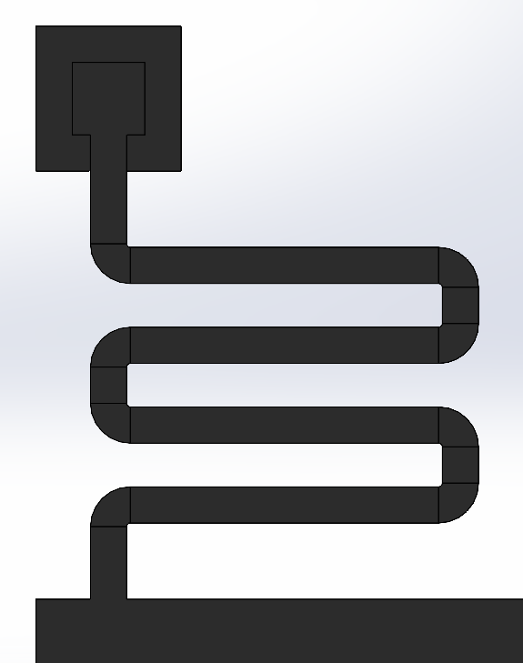 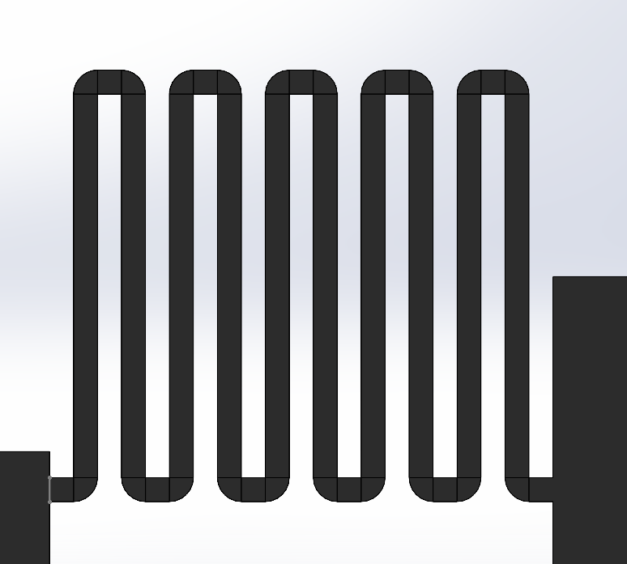

***Figure 1: Spring A*  *Figure 2: SPRING B***

**(Between Anchor and Actuator) (Between Actuator and Platform)**

**Initial Designs**

In the initial round of manufacturing, three different designs were assessed. The main variable in these designs was the stiffness of Spring B, which was varied via spring leg length, number of turns in the spring, and the width of the spring U-turn.

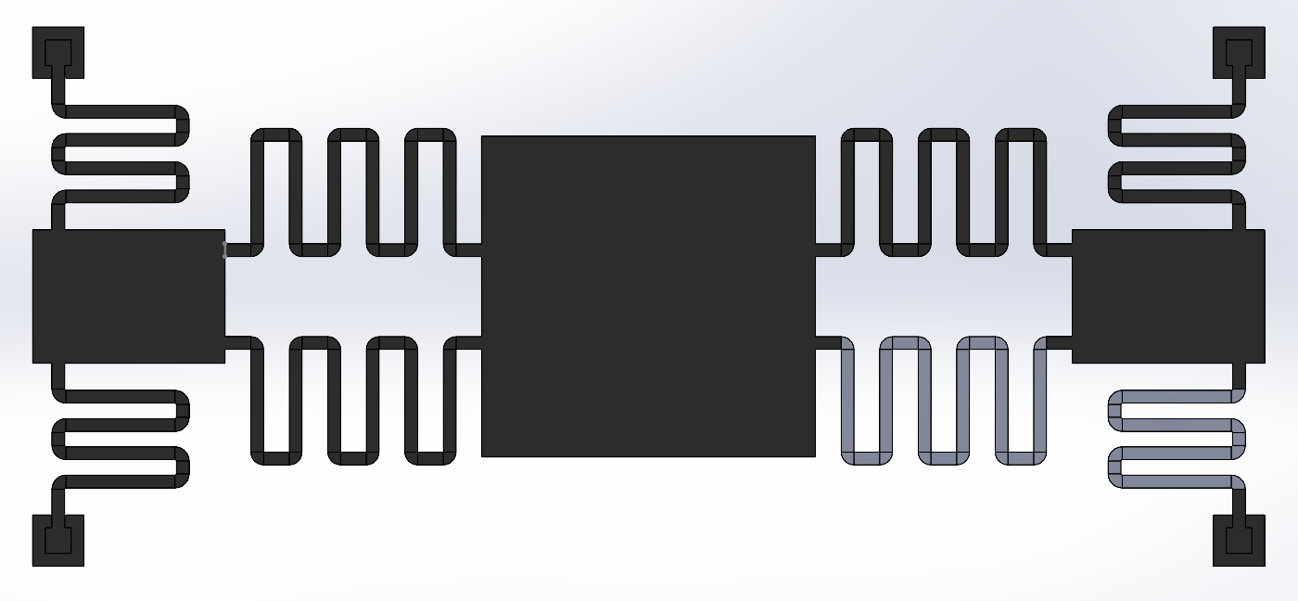

***Figure 3: Concept A - High Stiffness Spring B***

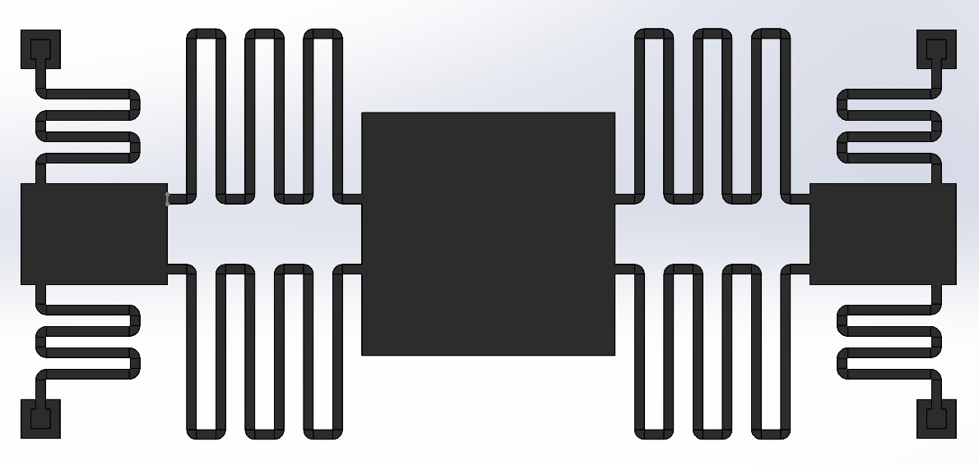

***Figure 4: Concept B - Medium Stiffness Spring B***

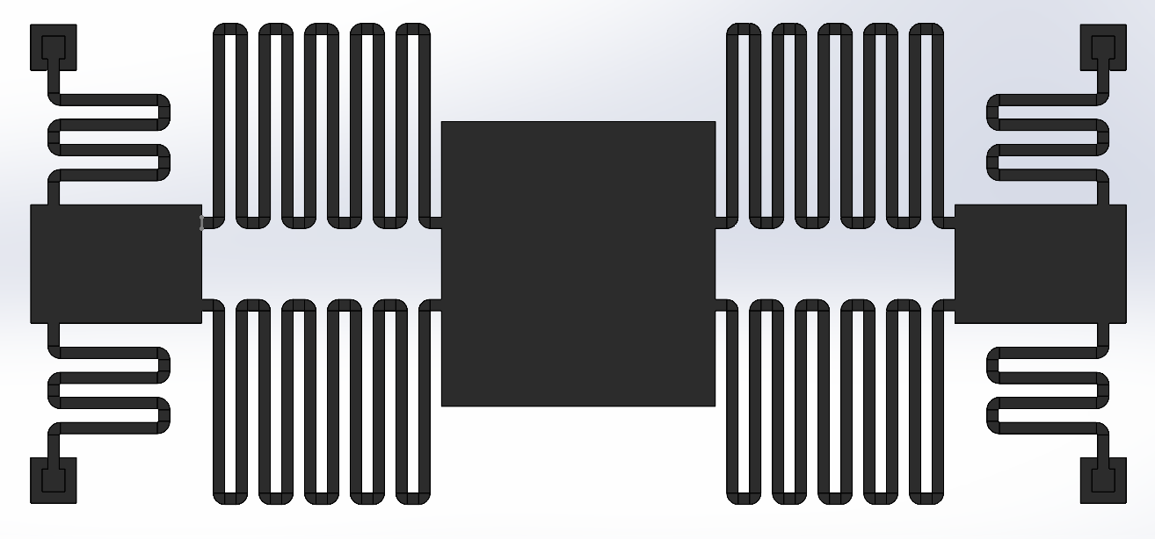

***Figure 4: Concept C - Low Stiffness Spring B***

## SOLIDWORKS Simulation Setup - Phase 1

For the first set of SOLIDWORKS Simulations, each of the four anchors were assigned a fixed zero-displacement condition. In addition, two horizontal forces (0.0005 N) and two vertical forces (0.0005 N) were applied to the Tsang Actuators as shown in Figure 5.

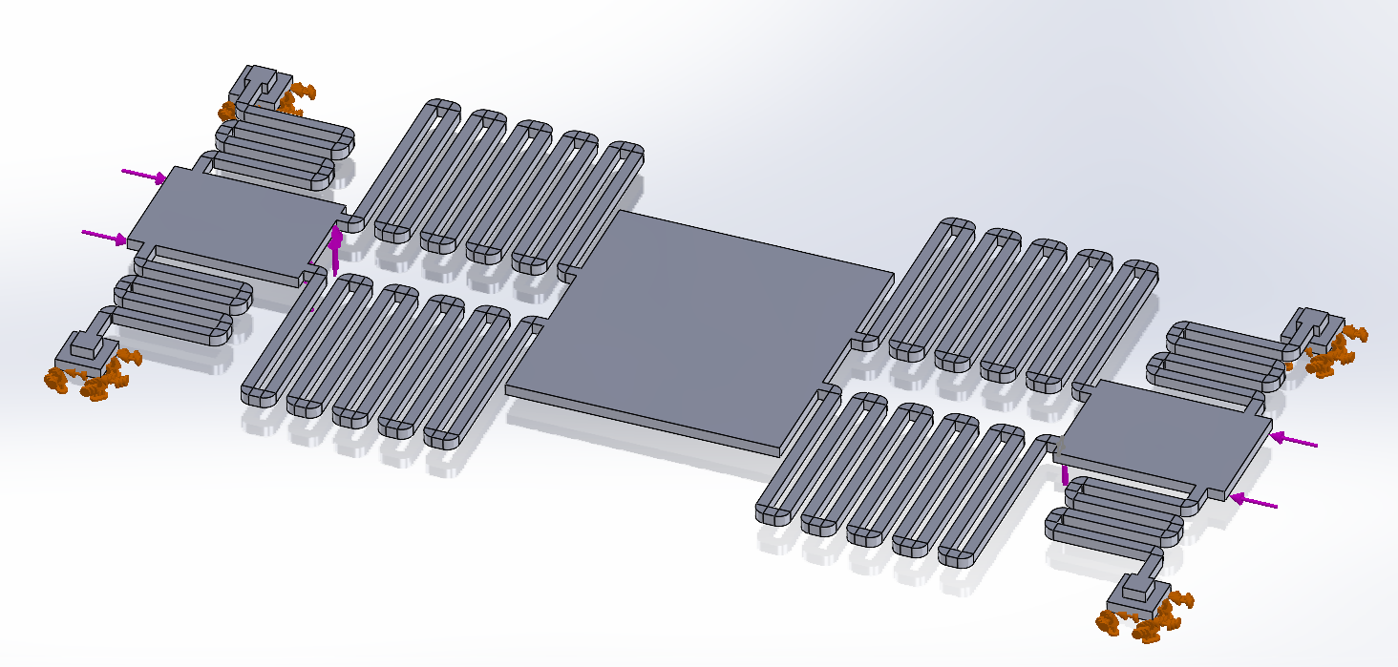

***Figure 5***

The following SU-8 material properties were obtained from the ENGR 406 Lecture Notes and a materials profile was created in SOLIDWORKS:

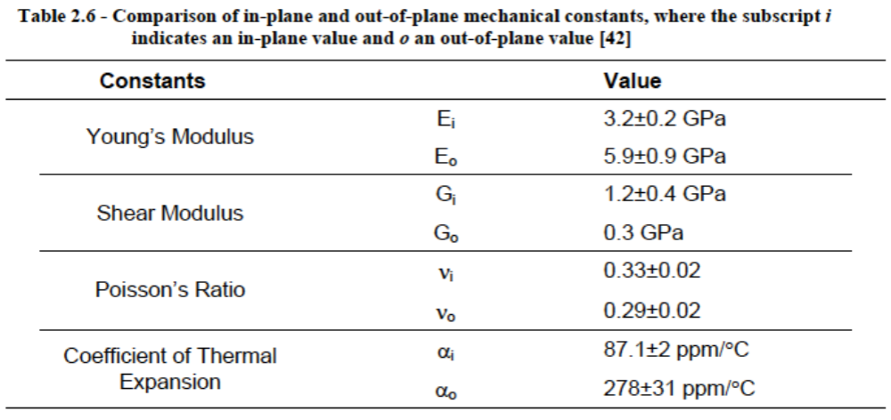

***Figure 6: Material Properties as sourced from ENGR 406 Slides***

While the force boundary conditions were close enough to reality, they were not exact. The first set of simulations had two assumptions. Firstly, the simulations allowed the springs to displace out of plane below what would usually be the substrate. However, because the magnitude of this deflection was minor, it was assumed to have a minor effect on the stress distribution within the Tsang Assembly. Another assumption within the model was the friction boundary condition at the substrate. The model did not include a physical substrate and hence no friction and normal force was considered between Spring A and the substrate. While this is an important boundary condition, it was not considered for the first set of simulations as it was thought to have a limited impact on the stress distribution.

The purpose of this first pass simulation was to determine the stress distribution within the model for a provided set of boundary conditions. The results were used to quickly iterate and optimize the design virtually by reducing the overall magnitude of the Maximum Von Mises Stress for a constant loading. Due to the approximation of boundary conditions the exact magnitude of the maximum stress was not as important to evaluate, as the results were based on a randomly chosen constant Force and Moment, and an approximation of boundary conditions. It was left up to testing to verify and validate the accuracy of the simulations in terms of a Crack or No Crack criteria. An example of the simulation validation in this regard would be the plastic deformation or failure of a spring in simulation and a similar outcome during testing.

## 

## Simulation Results - Phase 1

Simulation Results from Phase 1 showed that Design A had the lowest stress at 30.9MPa, including stress concentrations. Since this stress was less than the yield stress of SU-8 (34MPa), the team had little confidence that this design would work.

## 

***Figure 7: Phase 1 Simulation Results***

Although the other designs had a higher maximum stress, they were still fabricated in case future testing showed the simulation numbers were incorrect.

The stress distribution from the simulations pointed that the location of the maximum stress was at **either end of Spring A** as shown below:

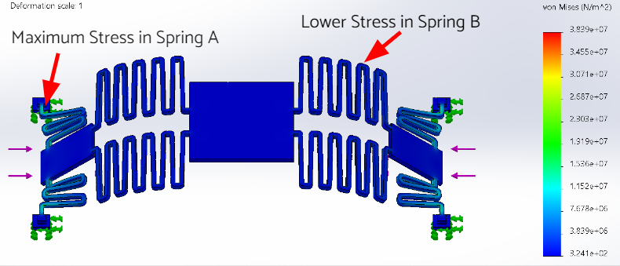

***Figure 8: Stress Distribution***

## Layouts - Phase 1

The layouts for the design were designed using Klayout. The layouts are the same dimensions and materials as the SOLIDWORKS design, with some very minor changes to ensure the design rules were not violated. Anchors were added to ensure the devices would not wash away during release. As explained before, the differences between each design are the number of springs and the length of the springs. After each design was complete, the devices were placed into a 5mm x 5mm area to represent the die our devices would be fabricated on. Figures 9 and 10 show the layouts for our “golden” design, called Concept A, with and without dimples respectively. Figures 11 and 12 show the layouts for the devices on the 5mm x 5mm area.

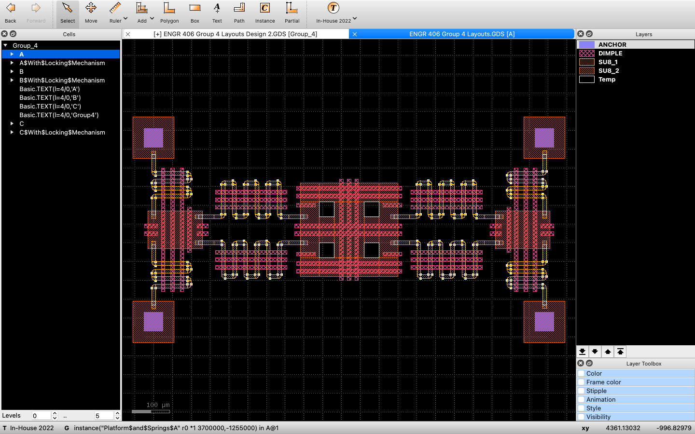

***Figure 9: Concept A Layout***

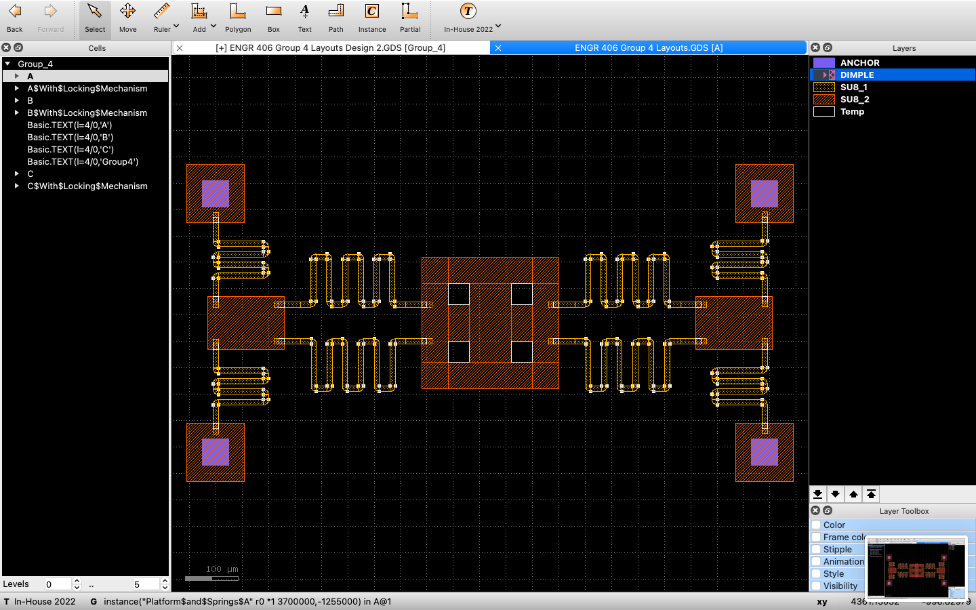

***Figure 10: Concept A Layout Without Dimples***

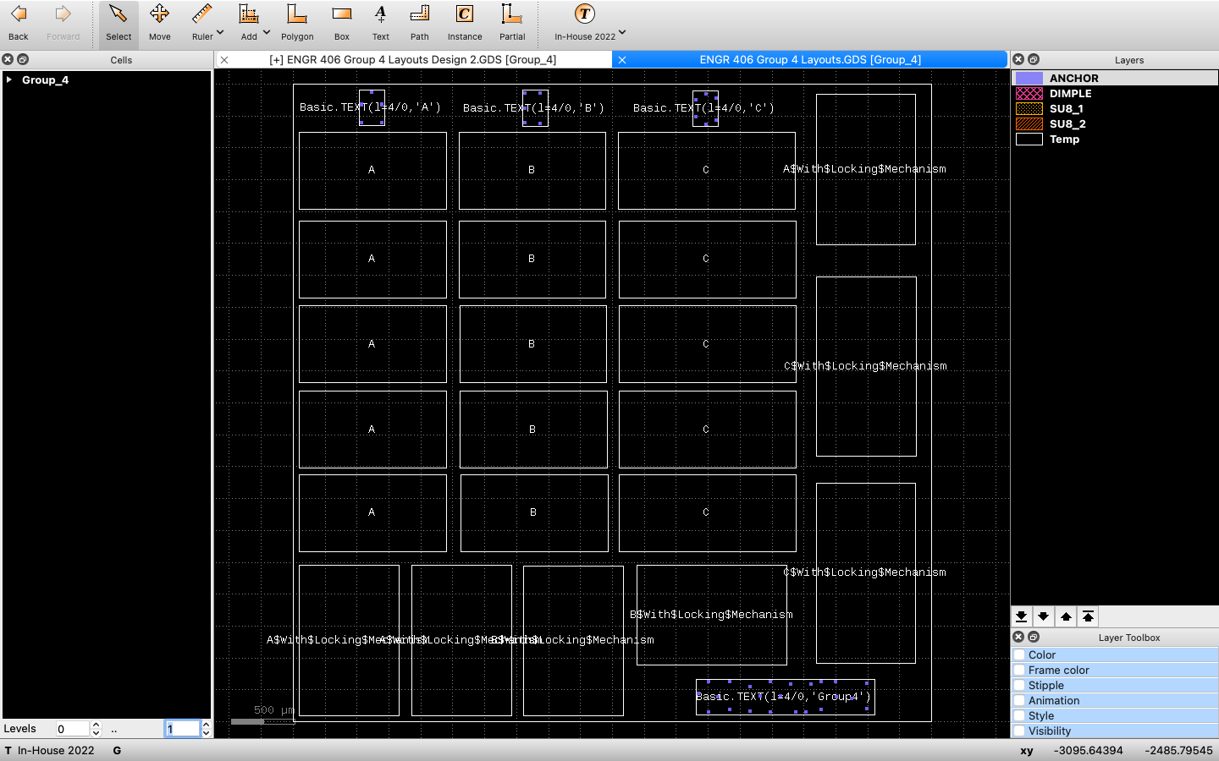

***Figure 11: 5mm x 5mm Chip Layout***

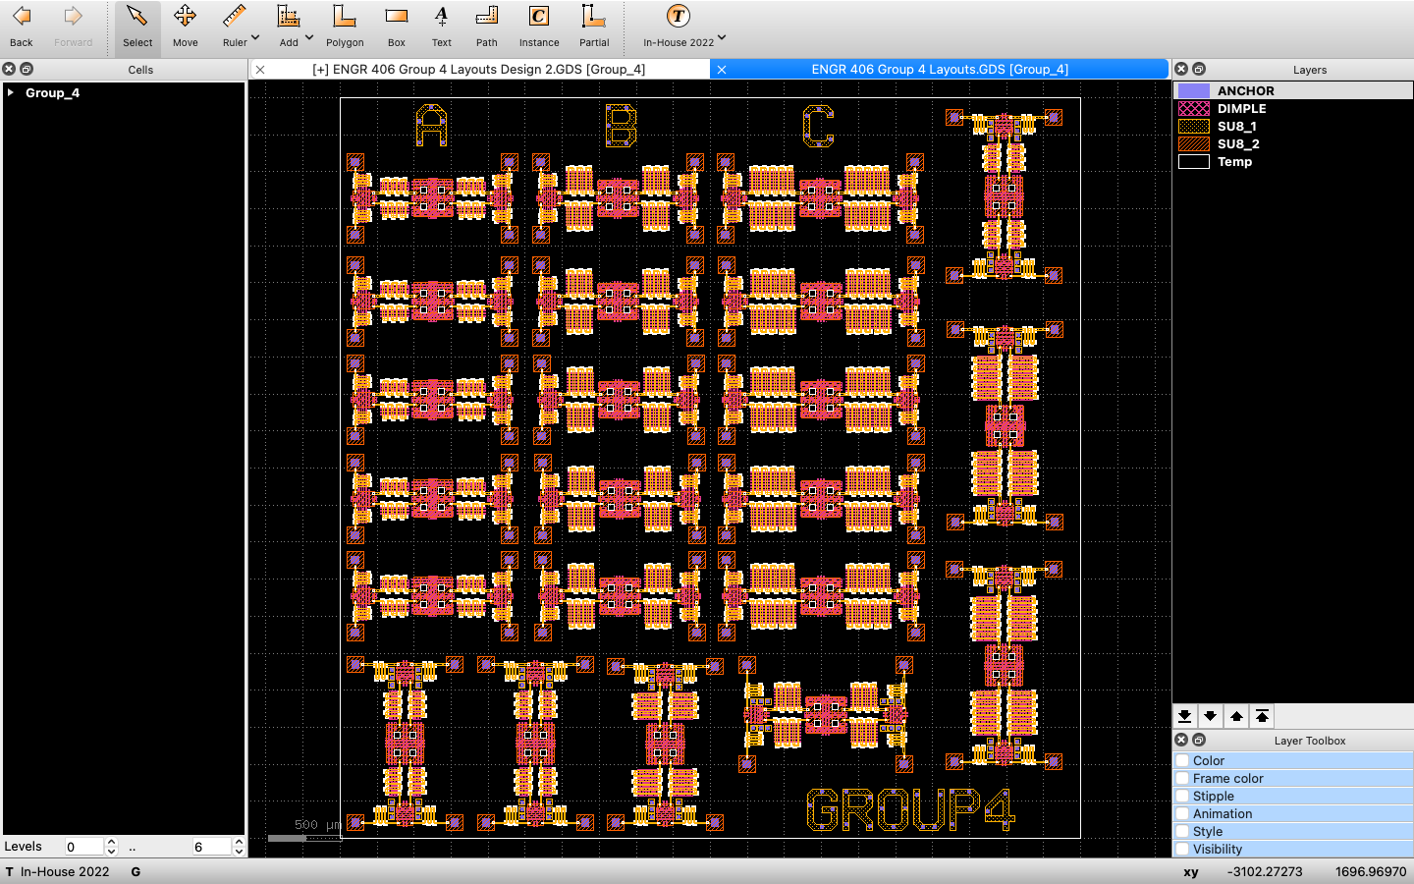

***Figure 12: 5mm x 5mm Chip Layout With Devices***

In addition to our main design, we also designed devices with a locking mechanism that would theoretically keep the tsang suspension at a 90 degree angle. The layouts with and without dimples can be seen in figures 13 and 14 respectively. The layouts for Concepts B and C, with and without a locking mechanism, can be found in Appendix A.

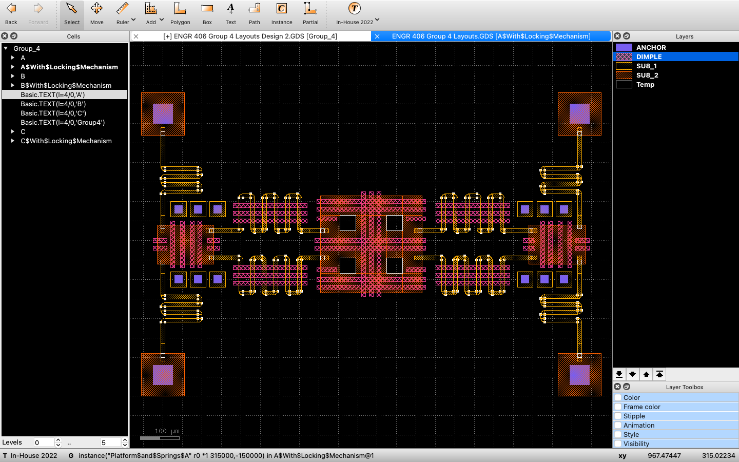

***Figure 13: Concept A Layout With Locking Mechanism***

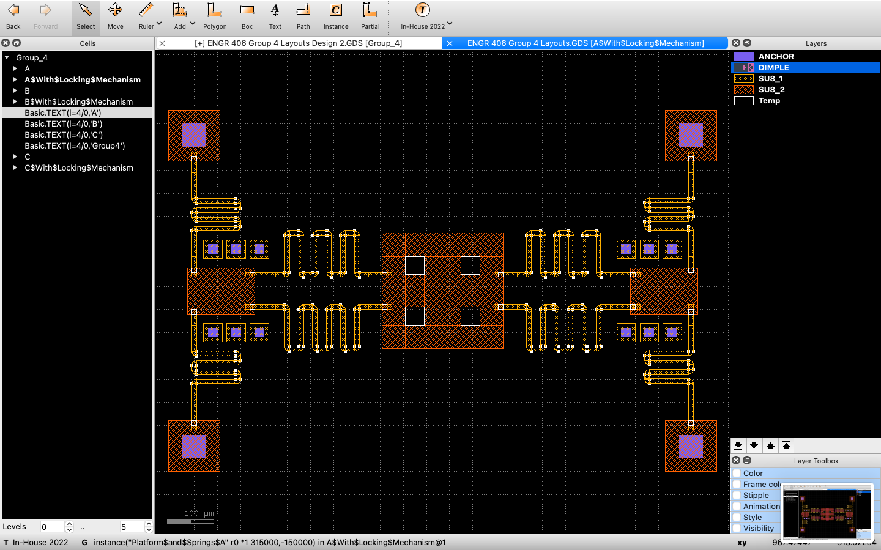

***Figure 14: Concept A Layout With Locking Mechanism and Without Dimples***

## 

## Test Plan - Phase 1

The layout on the chip was arranged to allow for the following tests with the assemblies in each of the Categories A, B, and C lined top to bottom according to the table below. The procedure for the testing was a straightforward process, with horizontal forces applied on the two actuating platforms on either end of the Tsang Assembly using a needle under a Scanning Electron Microscope. The performance criteria being assessed during the tests involved answering the following binary questions:

1. *Does the Tsang Assembly Break when forces are applied to the Actuators?* ***(Yes/No)***
2. *If the Tsang Assembly does not break, is it capable of staying stationary at 90 Degrees?* ***(Yes / No)***

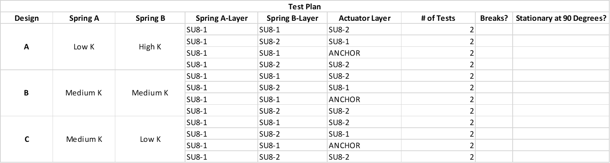

## Results - Phase 1

As shown in Table 1, the device we tested catastrophically failed because of Spring A breaking due to excessive stress before moving out of plane. Interestingly, the location of the failure during testing closely matched the location of maximum stress in the Solidworks Simulation. However, because the tests failed contrary to Simulation Results, the magnitude of the maximum stress in the simulations was not accurate. From these results, our group determined that a more accurate SOLIDWORKS simulation was required along with less stiff Spring A.

**Table 1:** Test Results of Initial Design

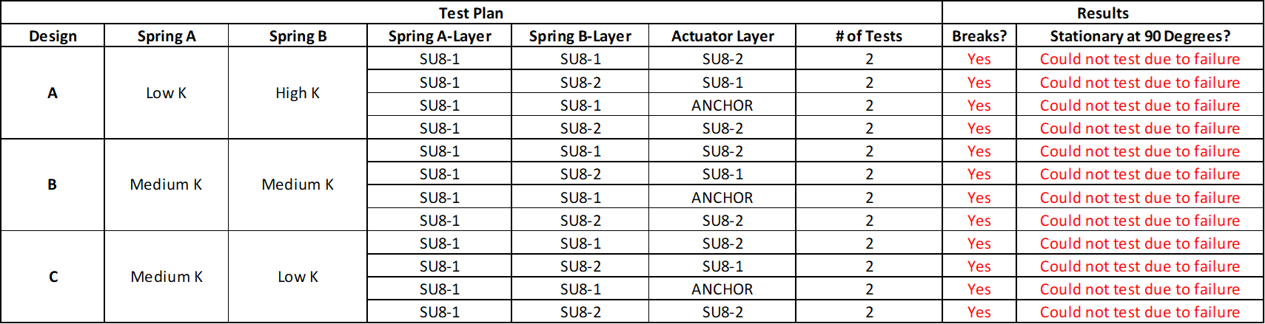

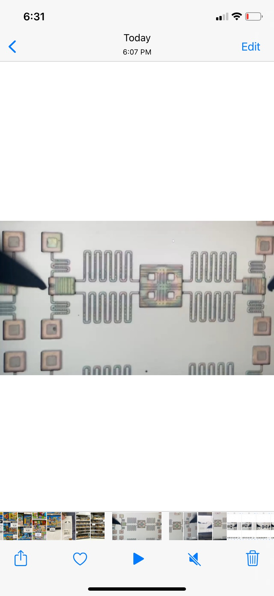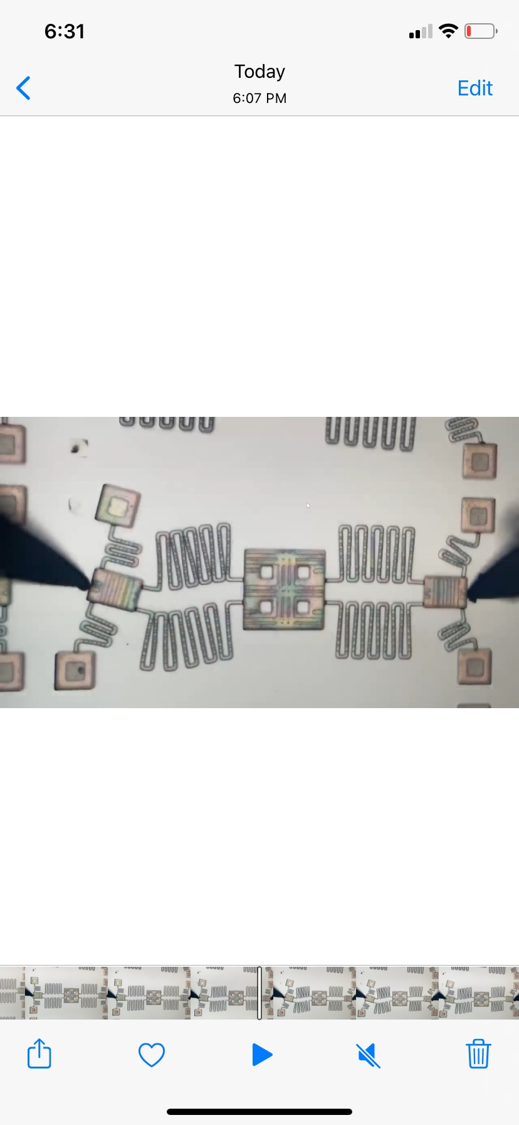

**Figure 15:** Catastrophic Failure of Concept B due to Unanchored Anchor (Left is Before Failure, Right is After Failure)

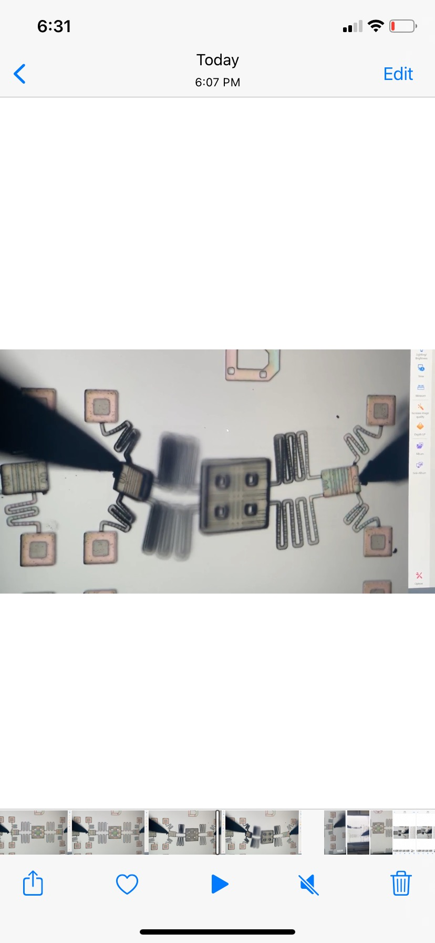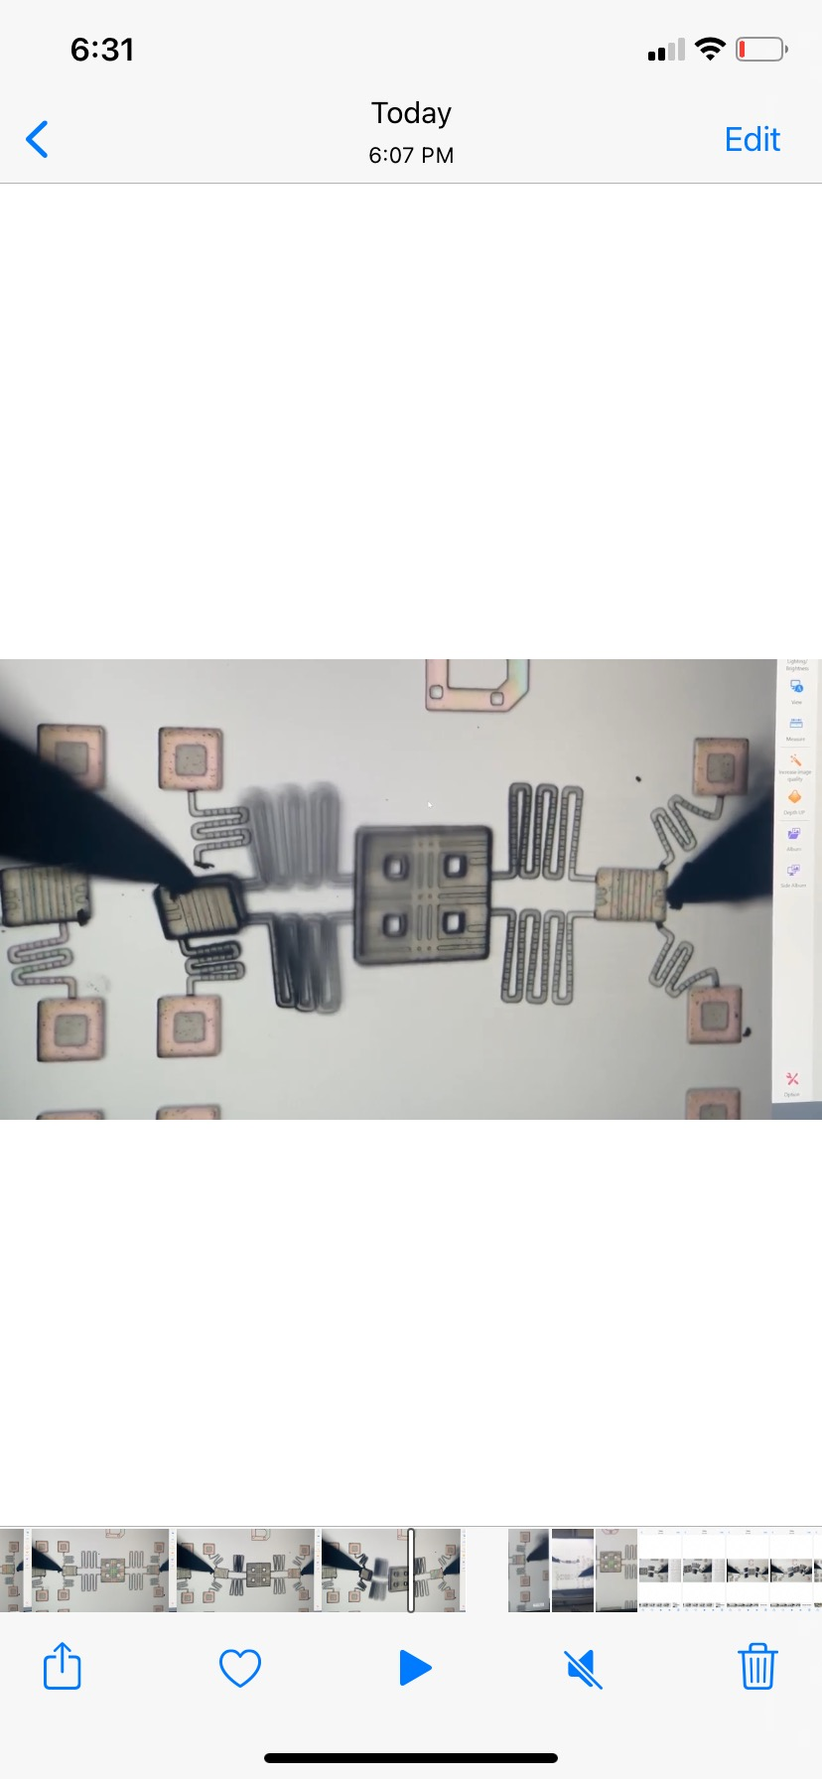

**Figure 16:** Catastrophic Failure of Concept B due to Failure of Spring Anchor(Left is Before Failure, Right is After Failure)

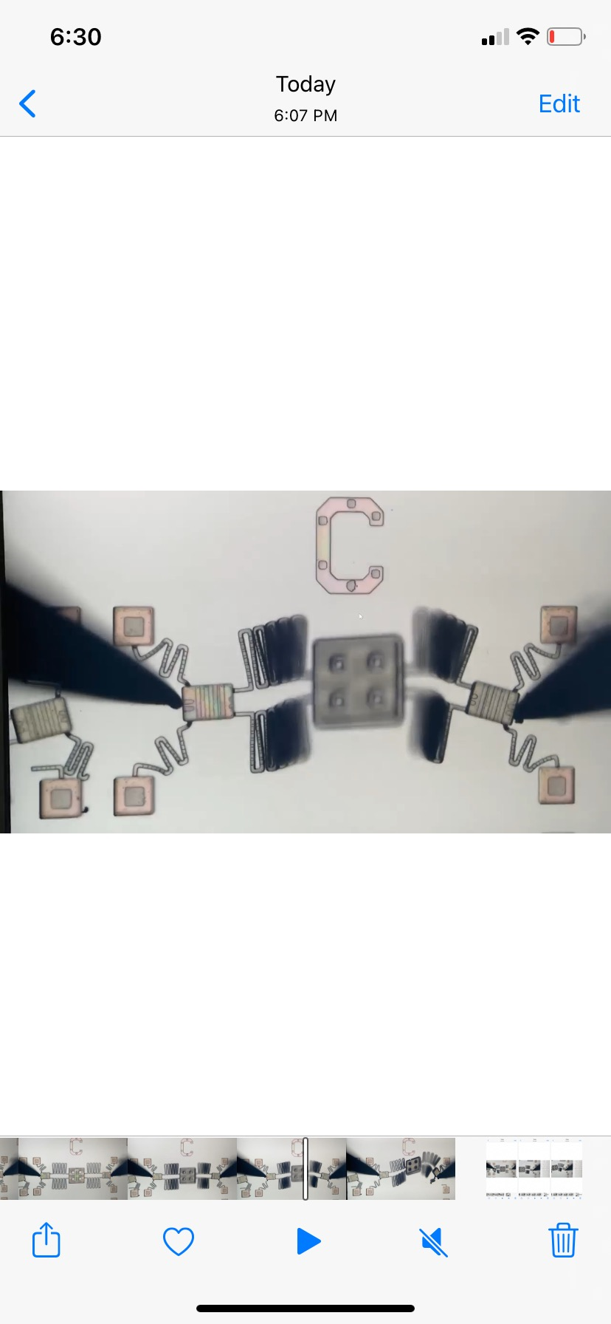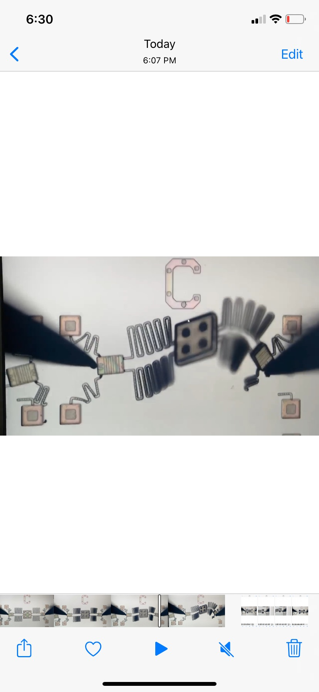

**Figure 17:** Catastrophic Failure of Concept C due to Failure of Spring Anchor(Left is Before Failure, Right is After Failure)

# 

# Final Designs

After seeing the catastrophic failures in Phase 1, the simulation model was improved. Instead of a linear model, a Non-Linear Large Displacement stress analysis was conducted. In addition, the boundary conditions were improved by adding a limit on the vertical deflection of Spring A to ensure that no part of it is allowed to go below the imaginary substrate surface during the simulation. Once the improved simulations were set-up, six new designs (Concept D, E, F, G, H, I) were created on Solidworks as shown below. All concepts were designed with significantly lower stiffness of Spring A.

**Figure 18 Concept D Figure 19 Concept E**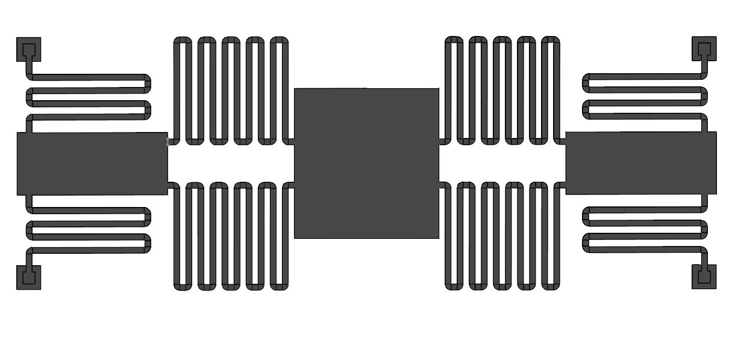 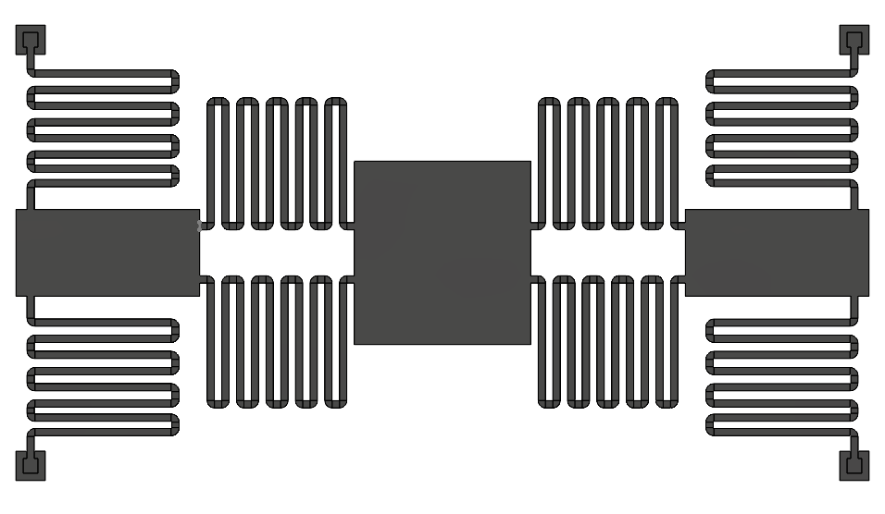

**Figure 20 Concept F Figure 21 Concept G**

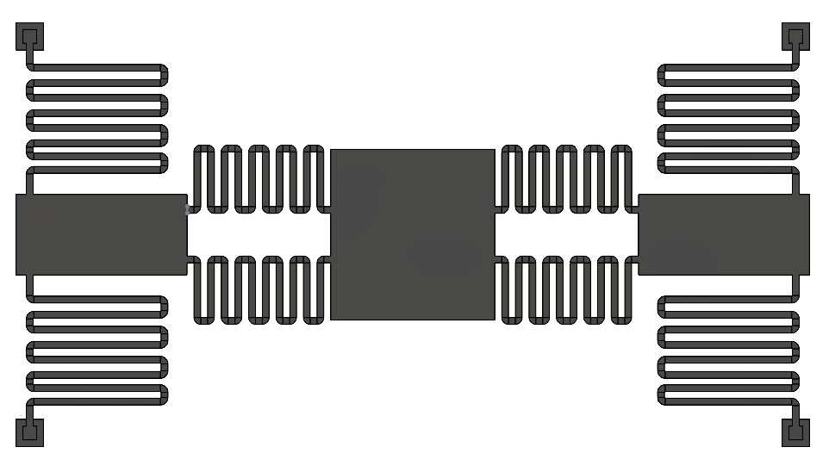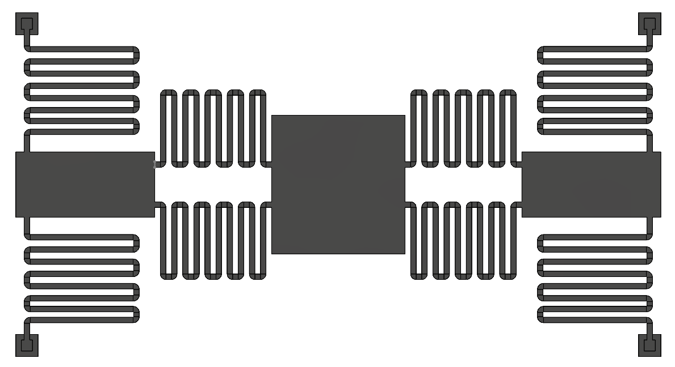

**Figure 22 Concept H Figure 23 Concept I**

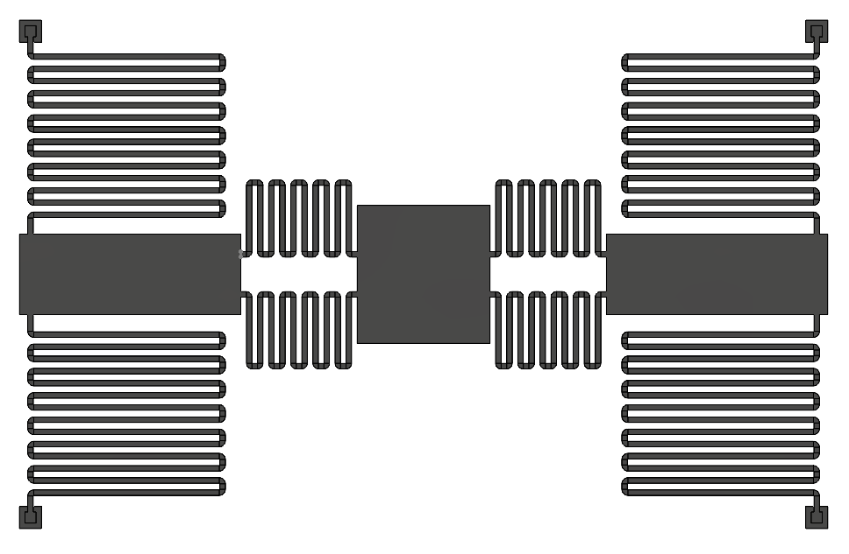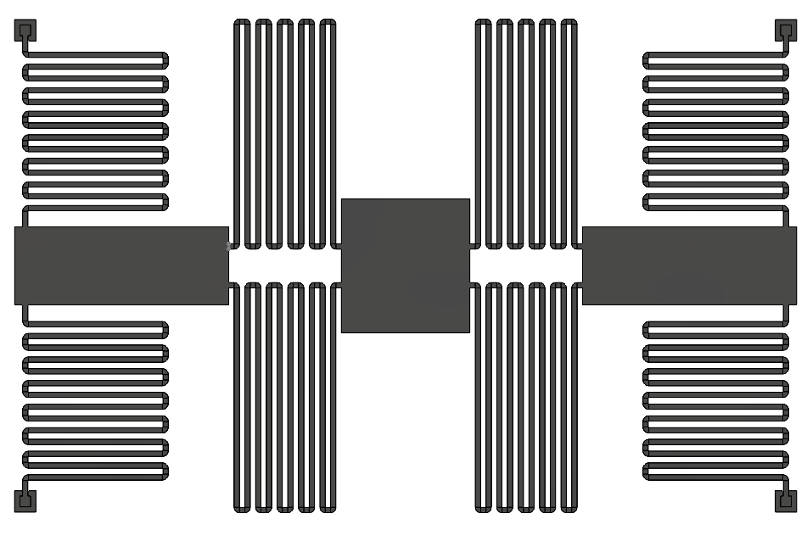

**Concept D:** Spring A Stiffness < Phase 1. Spring B, Platform - Actuator Distance unchanged

**Concept E:** Spring A Stiffness << Phase 1

**Concept F:** Spring A Stiffness << Phase 1, Spring B Stiffness >> Phase 1

**Concept G:** Spring A Stiffness << Phase 1, Spring B Stiffness > Phase 1

**Concept H:** Spring A Stiffness <<< Phase 1, Spring B Stiffness >> Phase 1

**Concept I:** Spring A Stiffness << Phase 1, Spring B Stiffness << Phase 1

## 

## Solidworks Simulations - Phase 2

Post-design, the improved simulations in Phase 2 were “validated” as they accurately confirmed that Phase 1 designs were failing due to excessive stresses that were many multiples greater than the yield stress of SU-8. The new stress levels from Phase 1 design were used as the baseline for measuring improvement in Phase 2. As shown below, the chosen Phase 2 Design H has a maximum stress that is 92% lower than the chosen design in Phase 1.

**Table 2: Stress Magnitudes in Phase 1 and 2 Designs as per improved simulations**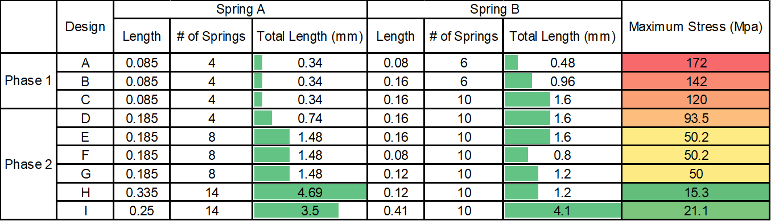

**Concept A Concept B**

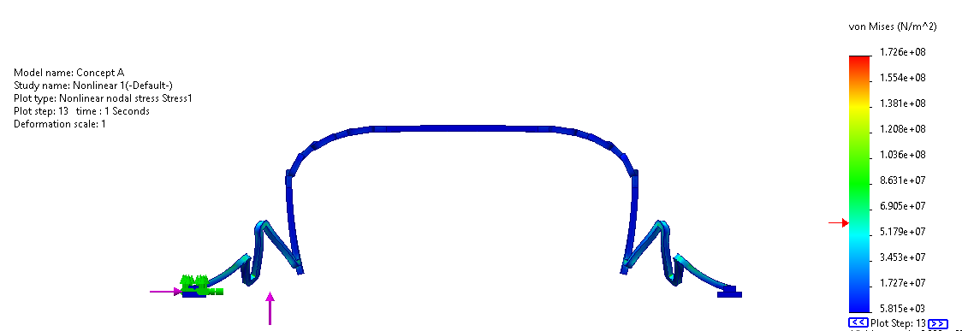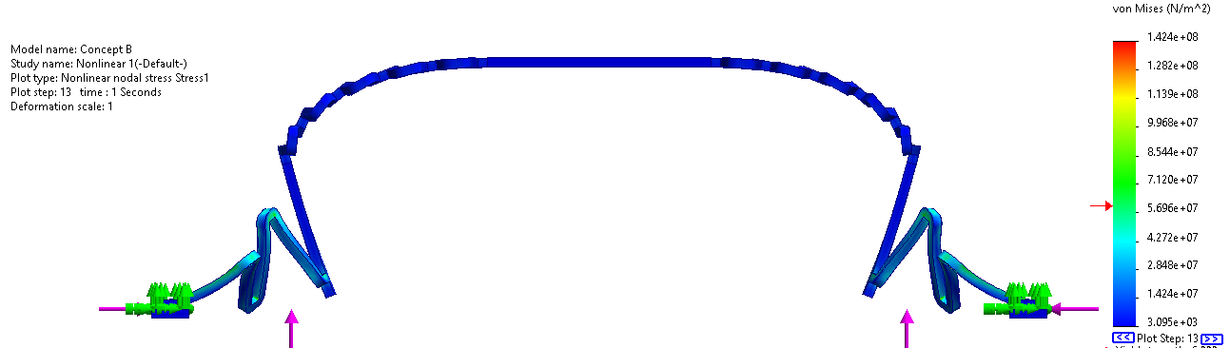

**Concept C Concept D**

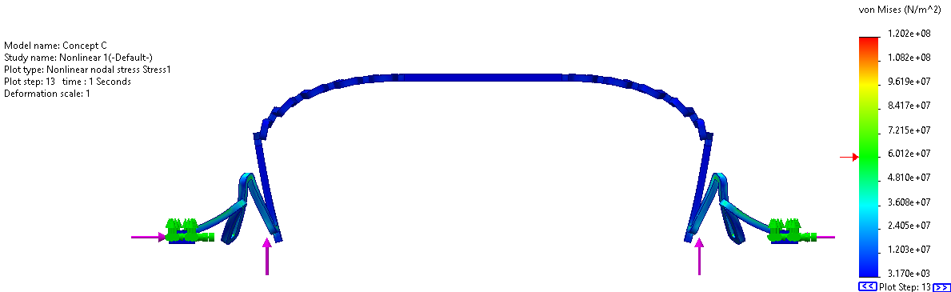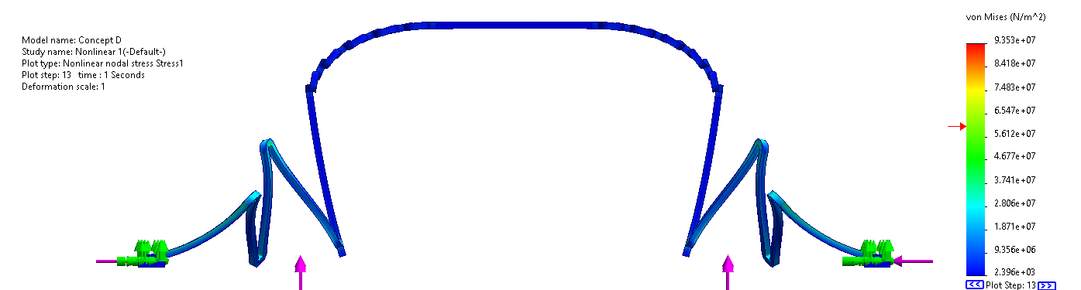

**Concept E Concept F**

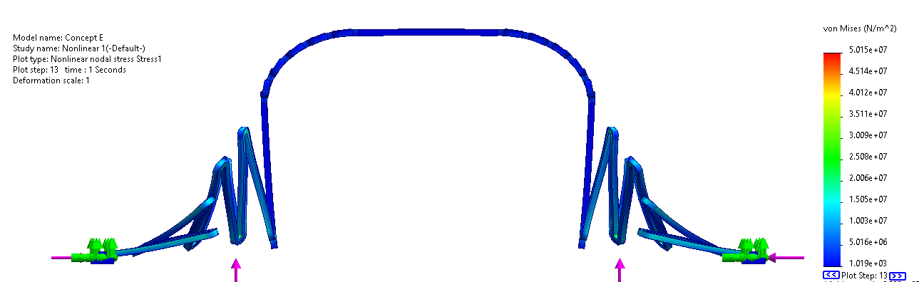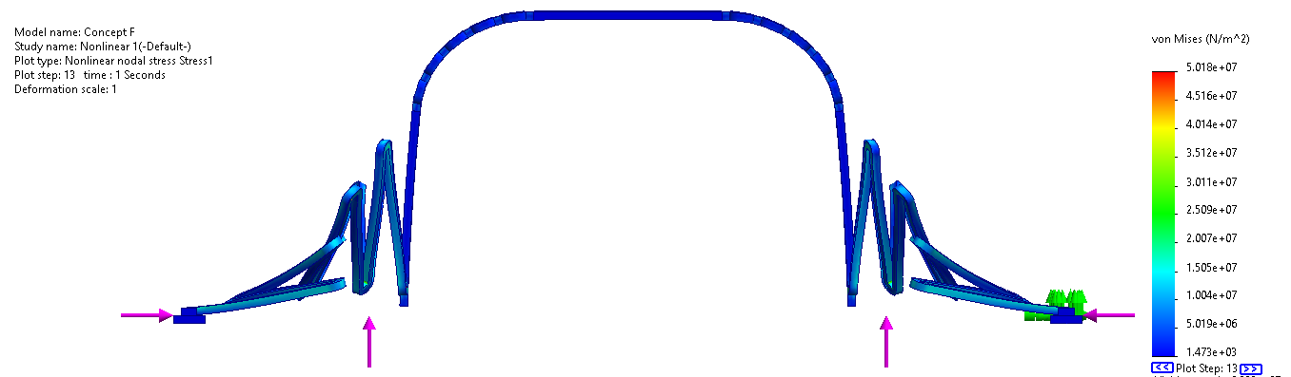

**Concept G Concept H**

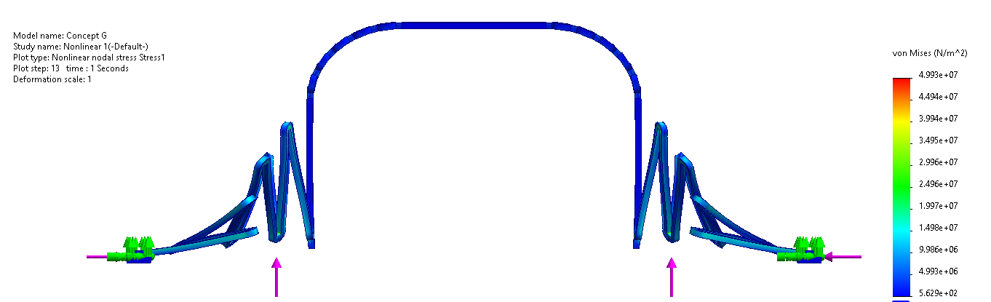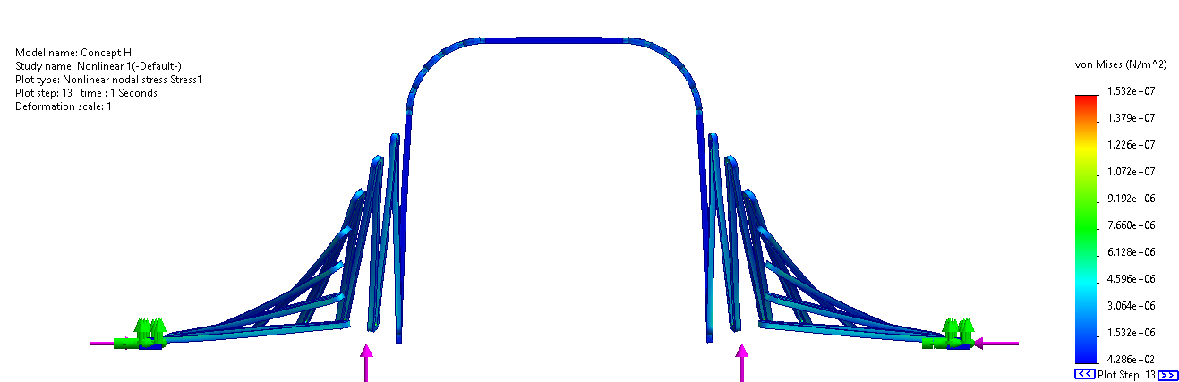

**Concept I**

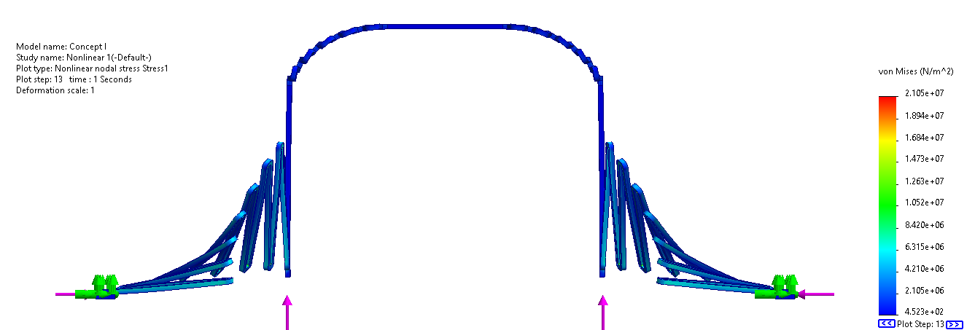

## Layouts - Phase 2

Once again, the layouts for the design were designed using Klayout and follow the same dimensions and materials as the SOLIDWORKS design. As explained before, there are six designs, concepts D, E, F, G, H, and I. In addition, we decided to not add any locking mechanism to our design as we are solely focusing on ensuring our devices will work as designed. Figures 25 and 26 show the layouts for our “golden” design, called Concept H, with and without dimples respectively. Figures 27 and 28 show the layouts for the devices on the 5mm x 5mm area. The layouts for Concepts D, E, F, G and I can be found in Appendix B.

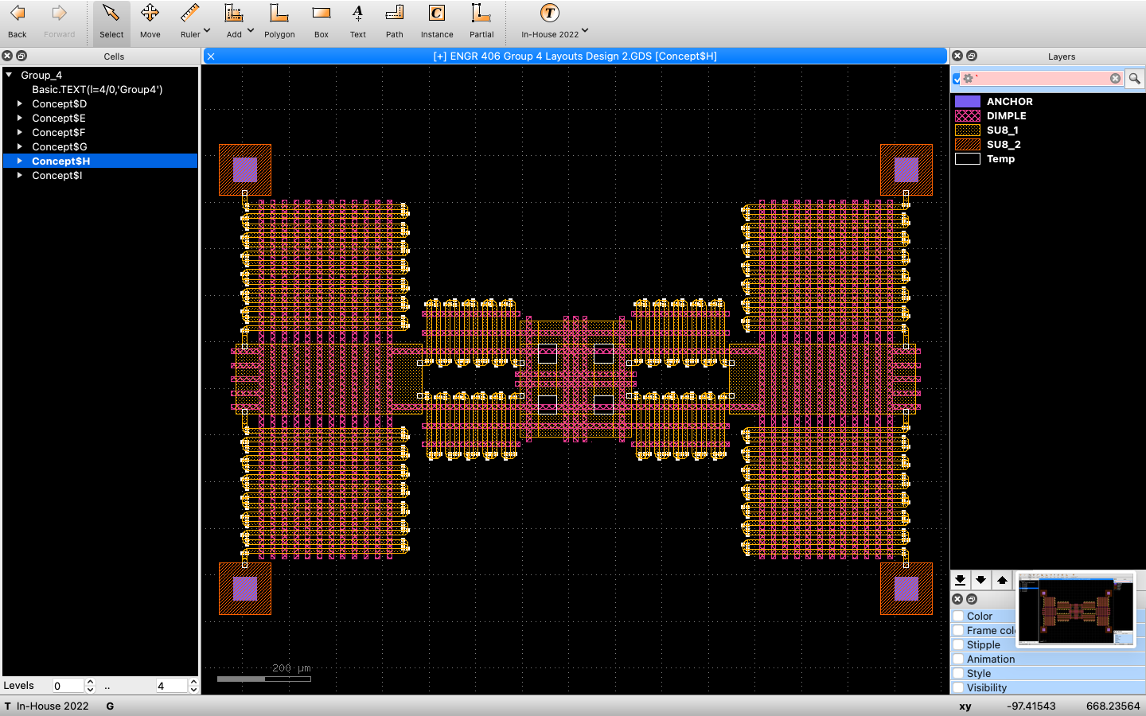

***Figure 25: Concept H Layout***

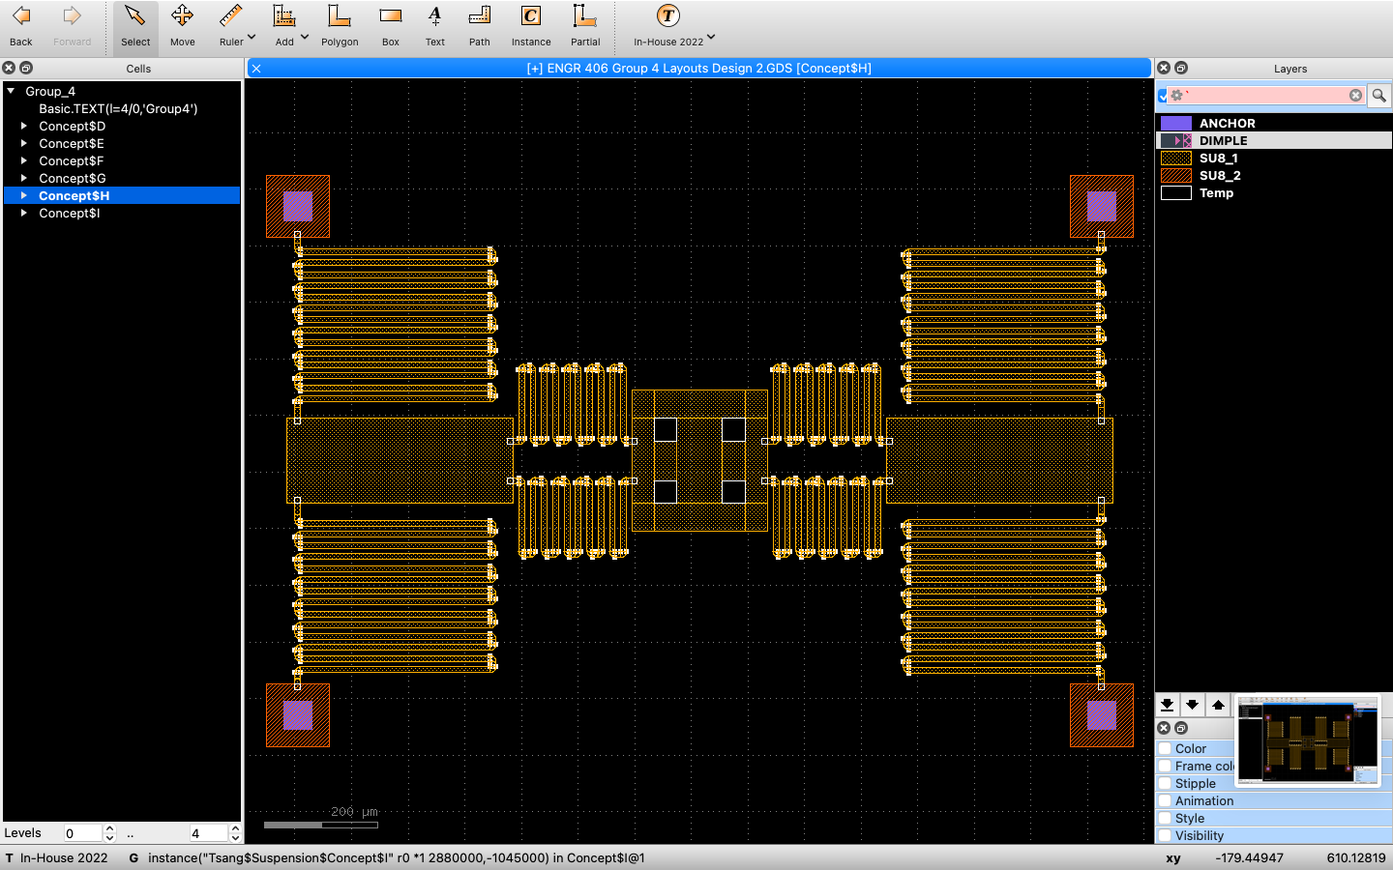

***Figure 26: Concept H Layout Without Dimples***

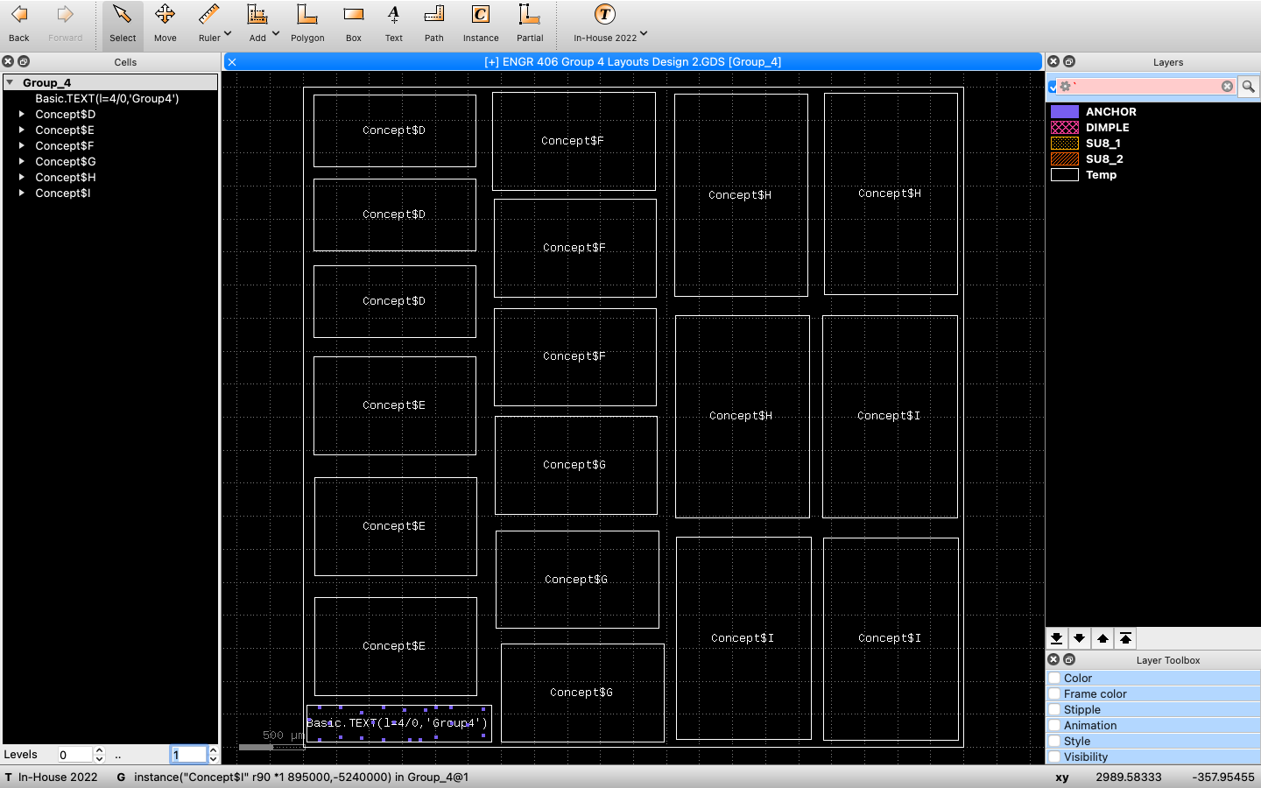

***Figure 27: 5mm x 5mm Chip Layout***

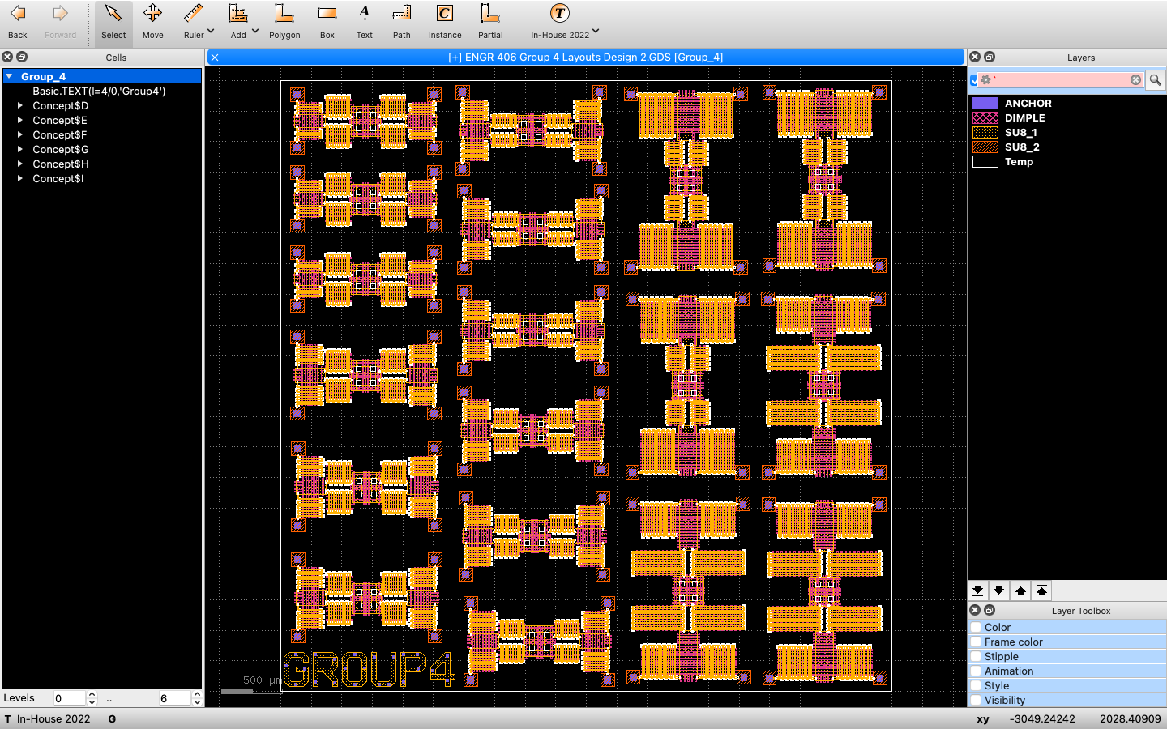

***Figure 28: 5mm x 5mm Chip Layout With Devices***

# Test Plan - Phase 2

The test plan for Phase 2 is the exact same for Phase 1. Three instances of each design concept are arranged on the Chip as per the layout in Figure 27. Upon testing, two MEMS needles should be used to simultaneously deliver inward horizontal forces on the actuators on the side of each design. The assembly should be seen under a Microscope.

Upon testing, data and pictures should be taken to detail the following questions:

1. *Does the Tsang Assembly Break when forces are applied to the Actuators?* ***(Yes/No)***
2. *If the Tsang Assembly does not break, is it capable of staying stationary at 90 Degrees?* ***(Yes / No)***

# Conclusion

One of the key lessons learned from the first phase of the design process is the importance of accurately considering all relevant variables within the given MEMS system. During the phase 1 testing, one of the root-causes of failure was not taking into account Spring A **stiffness** as a variable, this led to excessive stress on this component and ultimately caused the designs to fail when exerted force upon. This learning concluded that when designing Spring A, it is important to minimize stiffness in order to reduce stress and improve its safety factor.

Furthermore, the simulations used during the design process accurately identified the location where the maximum stress would occur within the mechanism. This is an important finding, as it allows testor to focus on areas of the design where the stress is likely to be the highest. However, the **magnitude** of the predicted stress was significantly off, with the simulations underestimating the actual stress that the designs would be subjected to. This error is likely due to the use of **linear static simulation**, which is a relatively simple and limited model that is not well-suited to predicting the behavior of complex systems. Additionally, the **boundary conditions** used in the simulations were incomplete, which may have also contributed to the errors in the predictions. In order to improve the accuracy of the simulations and better predict the behavior of the designs, it will be necessary to use more advanced simulation techniques and define all relevant boundary conditions. This will help to ensure that the designs are able to withstand the forces and stresses they will be subjected to in the real world.

Using a **non-linear model** gave more accurate results than when a linear static simulation model was used. A non-linear model is better than a linear model because it is able to more accurately represent the real-world behavior of materials and objects. In a non-linear model, the behavior of materials and objects is not assumed to be constant and can change based on factors such as stress, strain, temperature, and other factors. This allows for more accurate predictions and simulations of how an object or material will behave in real-world conditions. Additionally, non-linear models can better handle complex shapes and geometry, as well as account for geometric nonlinearities such as bending, twisting, and buckling. MEMS simulations benefit from non-linear modeling because MEMS devices are typically made of materials that exhibit non-linear behavior, such as silicon and other semiconductors. These materials can change their physical properties, such as stiffness and elasticity, based on factors such as temperature, stress, and strain. Overall, these learnings demonstrate the importance of thoroughly considering all variables and selecting appropriate materials in the design process in order to avoid failure and ensure the success of the designs.

# 

# 

# References

University of Maryland, Baltimore County. (n.d.). SU-8 Photoresist for Microelectromechanical Systems (MEMS) Fabrication.

Castro, David & Arevalo Carreno, Armando Arpys & Rawashdeh, Ehab & Dechev, Nikolai & Foulds, Ian. (2014). Simulation of a Micro-Scale Out-of-plane Compliant Mechanism.

SPTS Technologies. (n.d.). SU8 Photoresist for Microfabrication.

Microfabrica Inc. (n.d.). Lithography in MEMS Fabrication.

The MEMS Journal. (n.d.). Tsang Suspension.

MEMS Engineering. (n.d.). Tsang Suspension.

Tsang, K.N. (1998). A New Suspension System for High-Resolution and Low-Frequency Motion of Microscale Structures. Journal of Microelectromechanical Systems, 7(4), 372-378.

Hsu, C., Guo, Y., Shieh, W., & Chen, C. (2013). Tsang suspension for high-aspect-ratio SU8 microstructures. Microelectronic Engineering, 108, 15-19.

# Appendix A

Figure 17 to 24 show the layouts of Concepts B and C, with and without dimples and a locking mechanism.

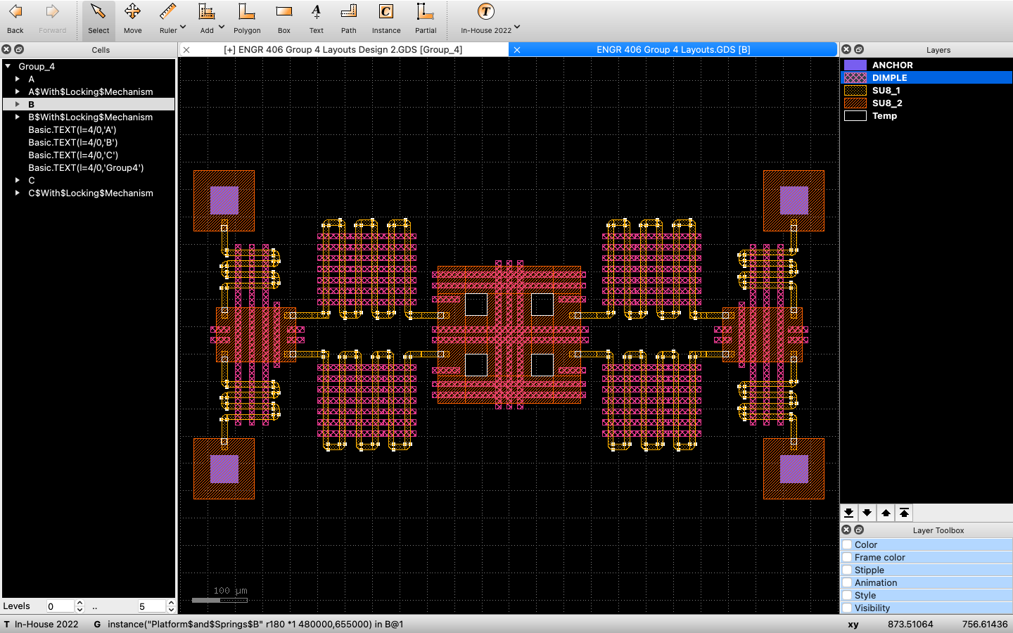

***Figure 17: Concept B Layout***

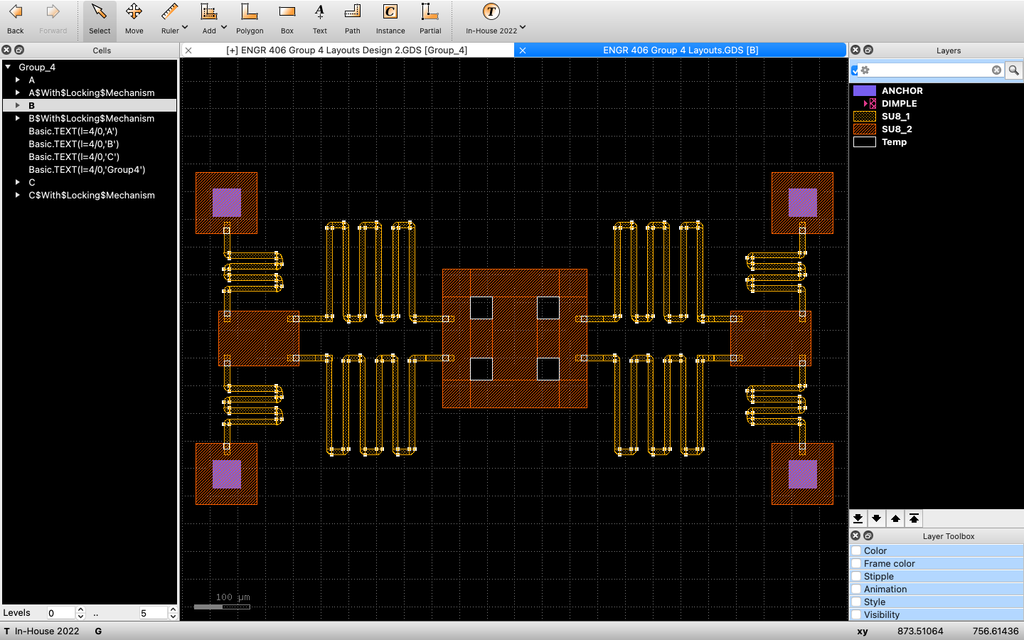

***Figure 18: Concept B Layout Without Dimples***

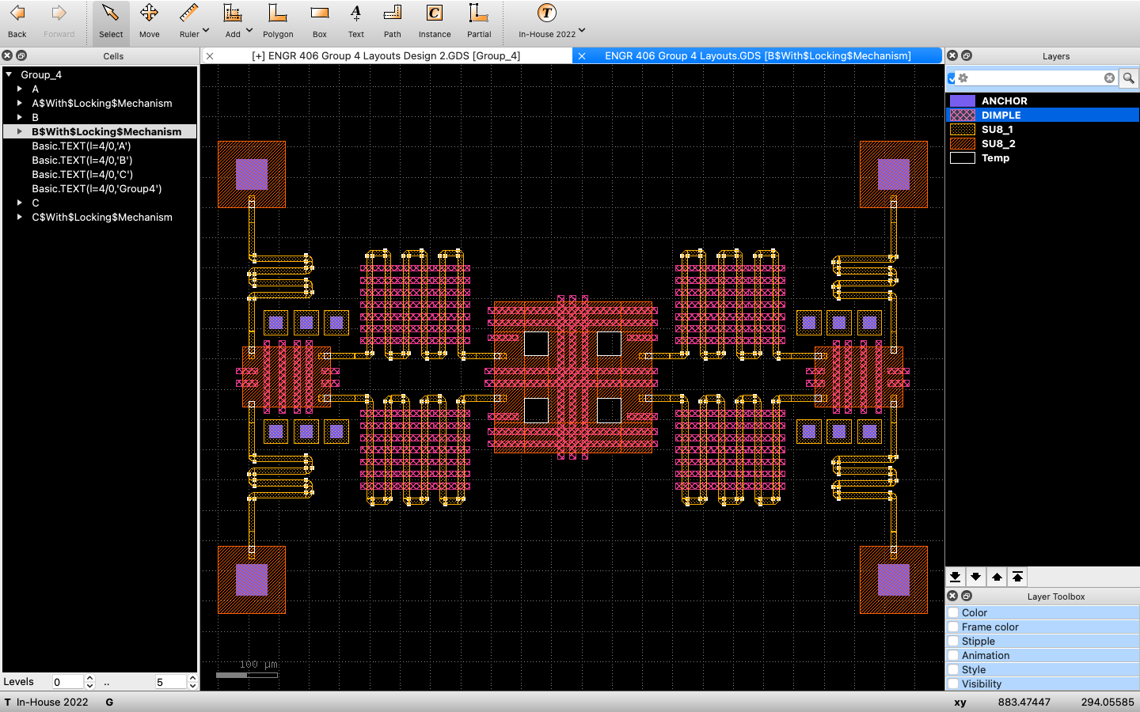

***Figure 19: Concept B Layout With Locking Mechanism***

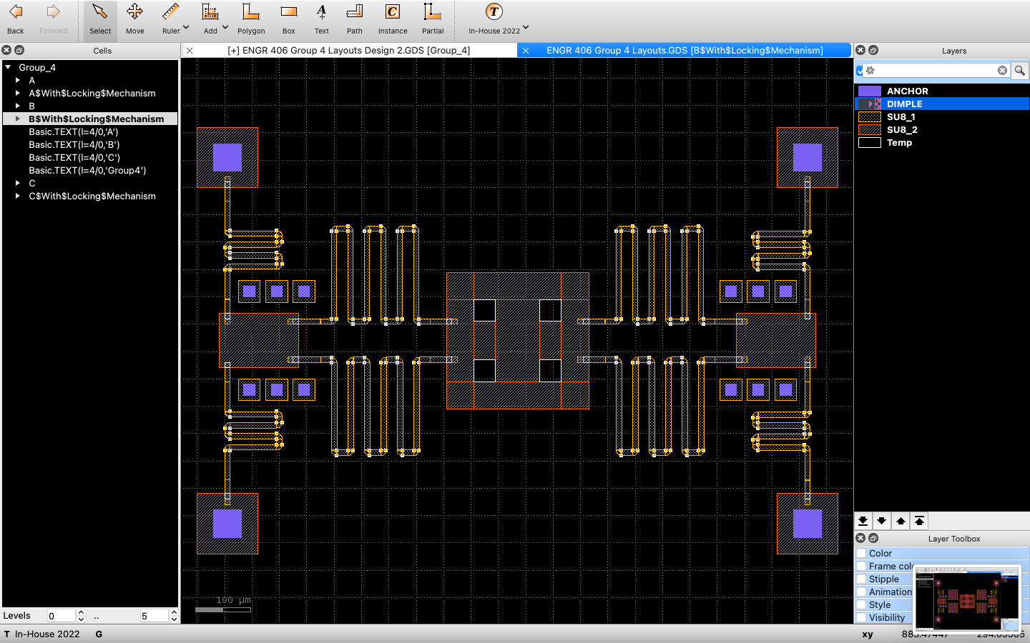

***Figure 20: Concept B Layout With Locking Mechanism and Without Dimples***

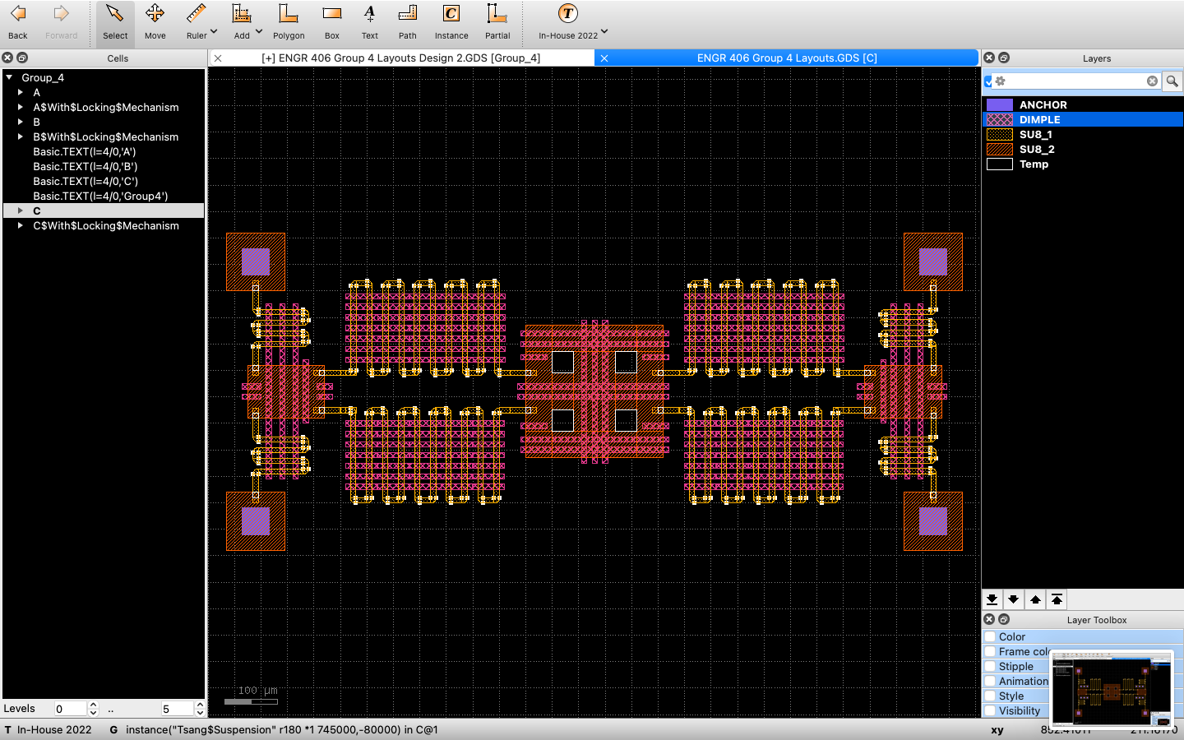

***Figure 21: Concept C Layout***

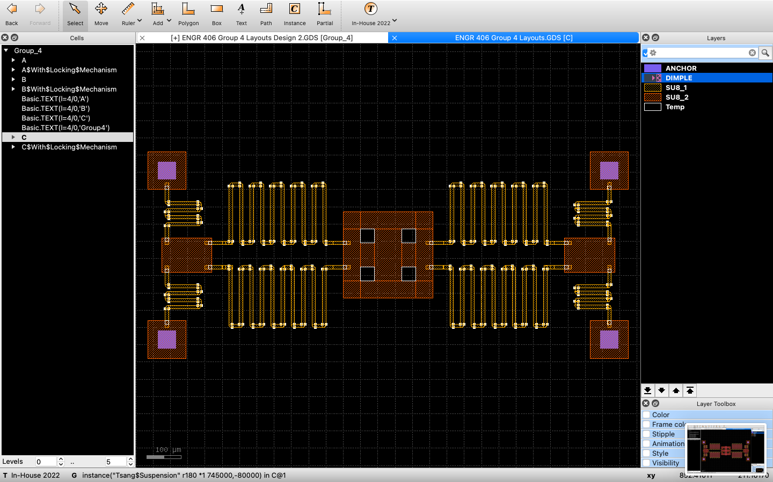

***Figure 22: Concept C Layout Without Dimples***

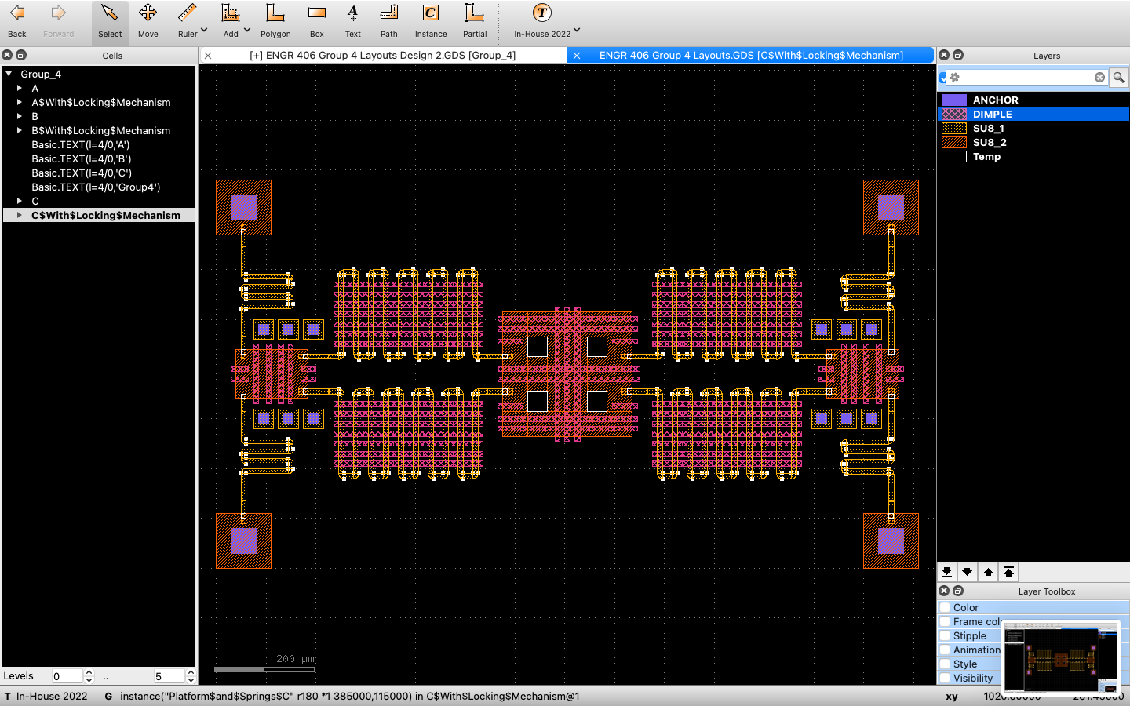

***Figure 23: Concept C Layout With Locking Mechanism***

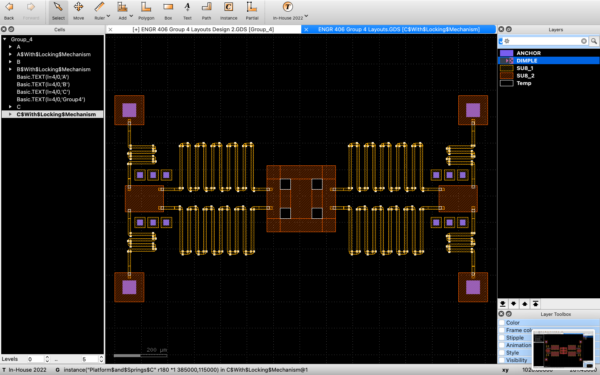

***Figure 24: Concept C Layout With Locking Mechanism and Without Dimples***

# Appendix B

Figure 25 to 34 show the layouts of Concepts D, E, F, G, and I, with and without dimples.

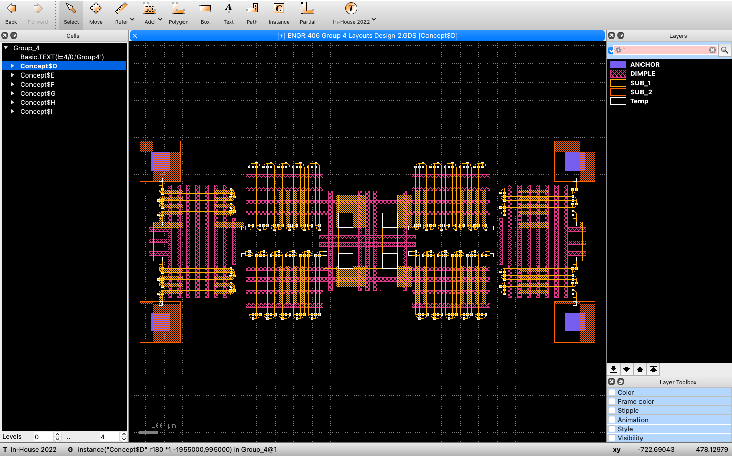

***Figure 25: Concept D Layout***

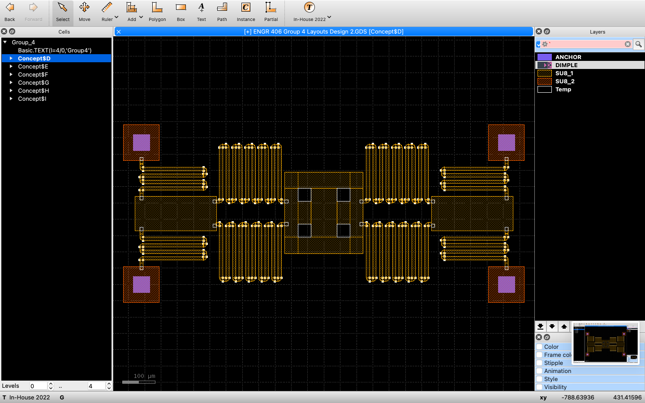

***Figure 26: Concept D Layout Without Dimples***

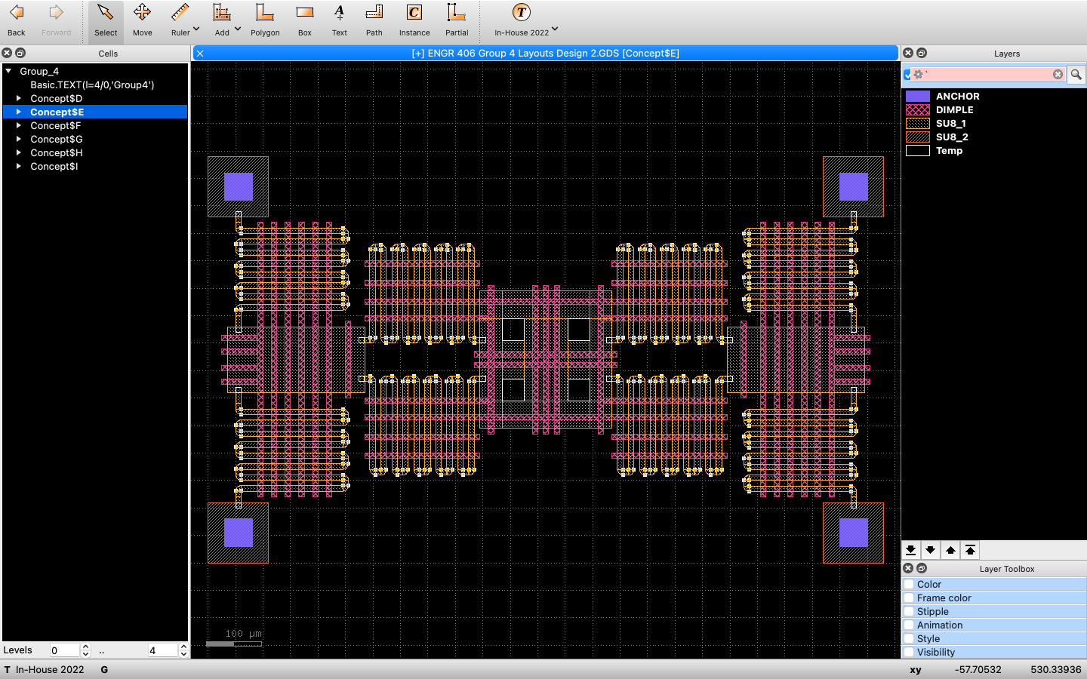

***Figure 27: Concept E Layout***

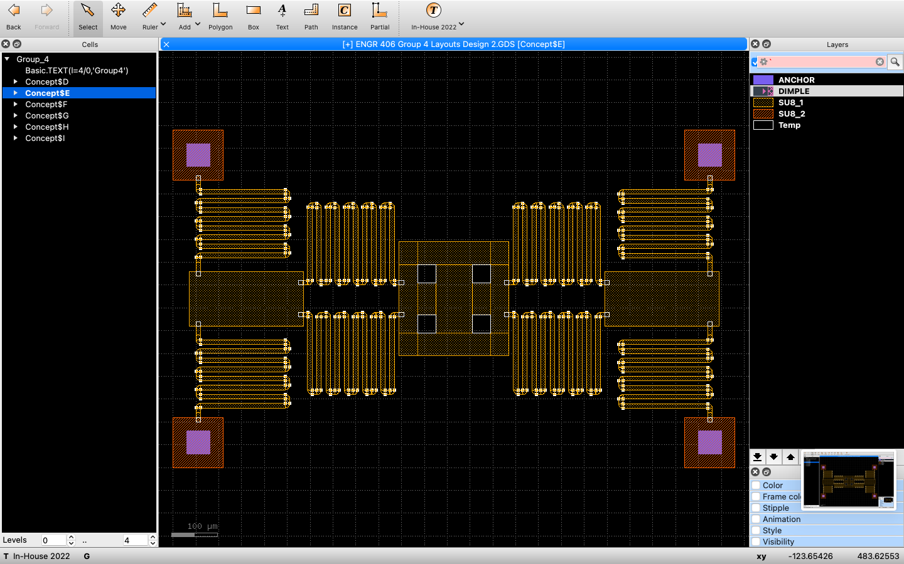

***Figure 28: Concept E Layout Without Dimples***

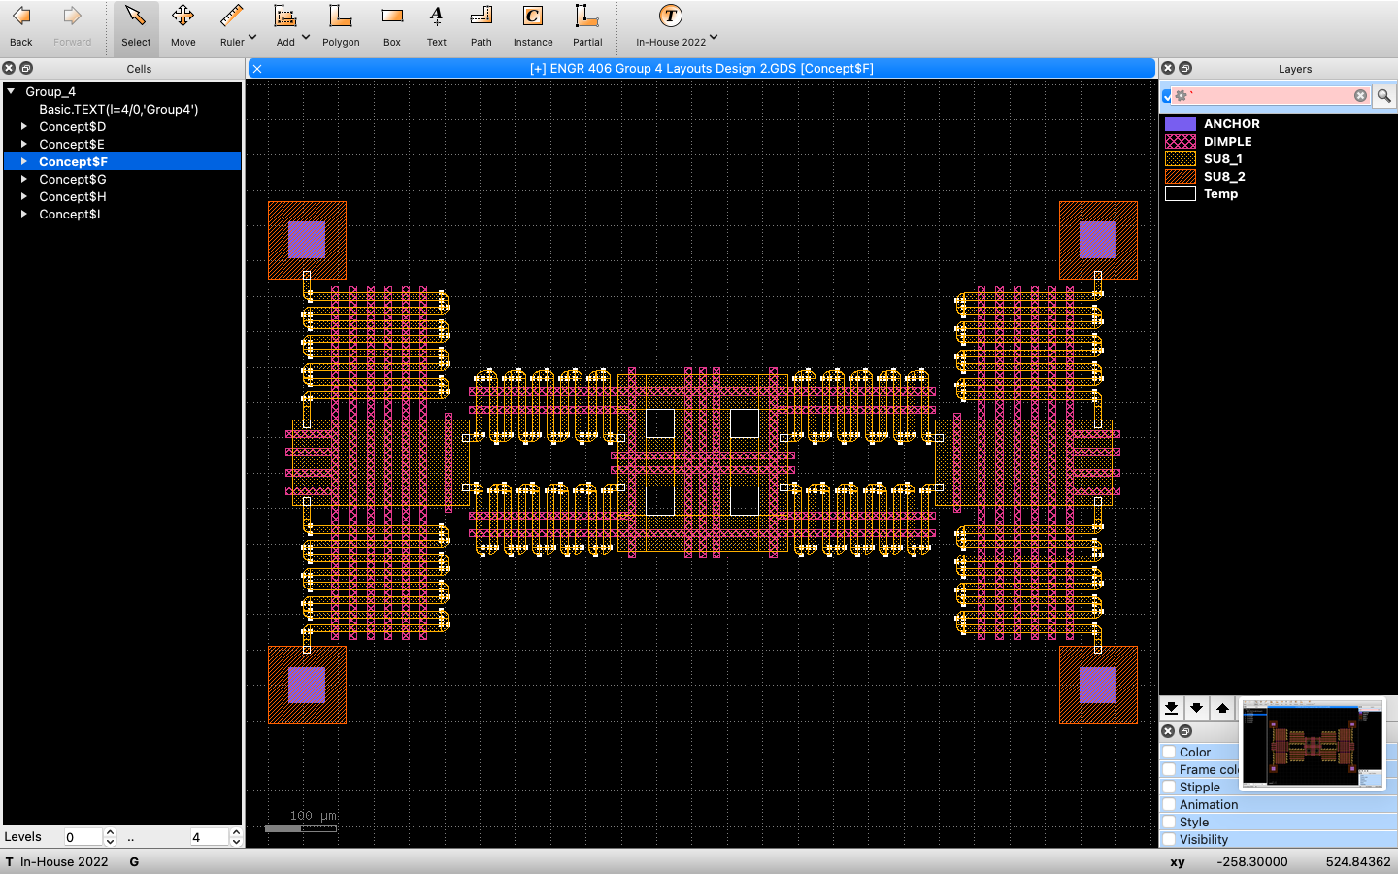

***Figure 29: Concept F Layout***

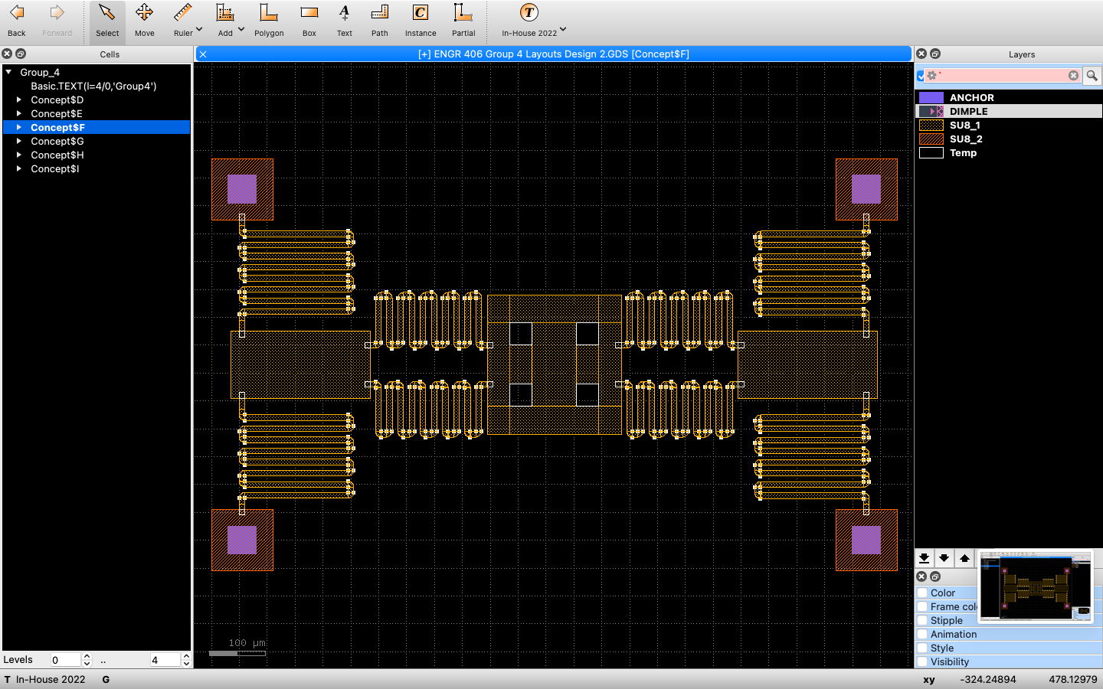

***Figure 30: Concept F Layout Without Dimples***

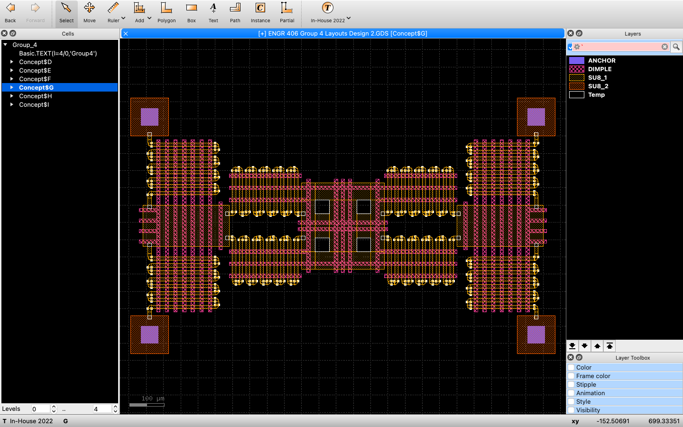

***Figure 31: Concept G Layout***

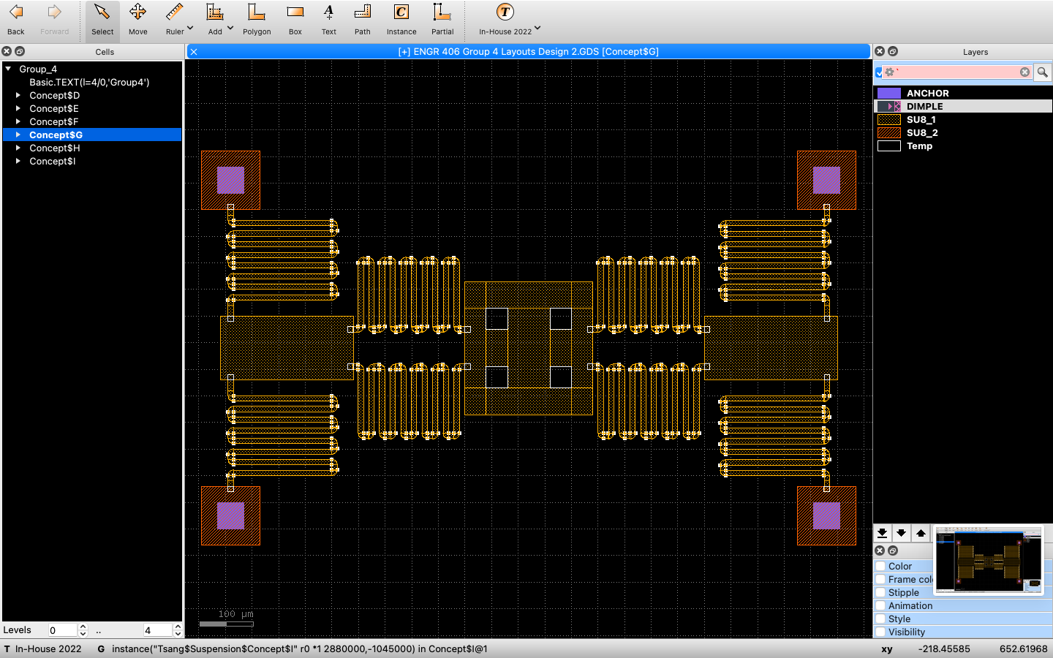

***Figure 32: Concept G Layout Without Dimples***

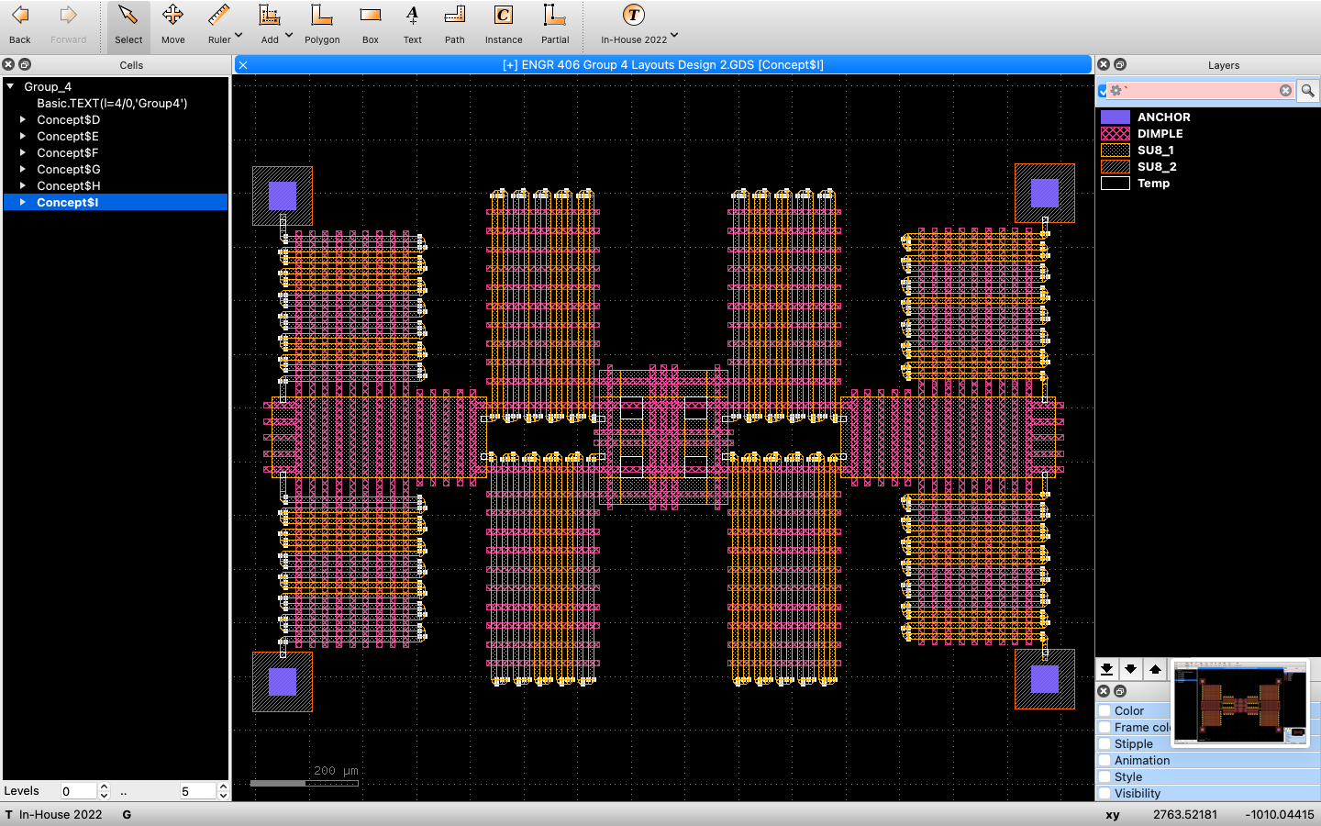

***Figure 33: Concept I Layout***

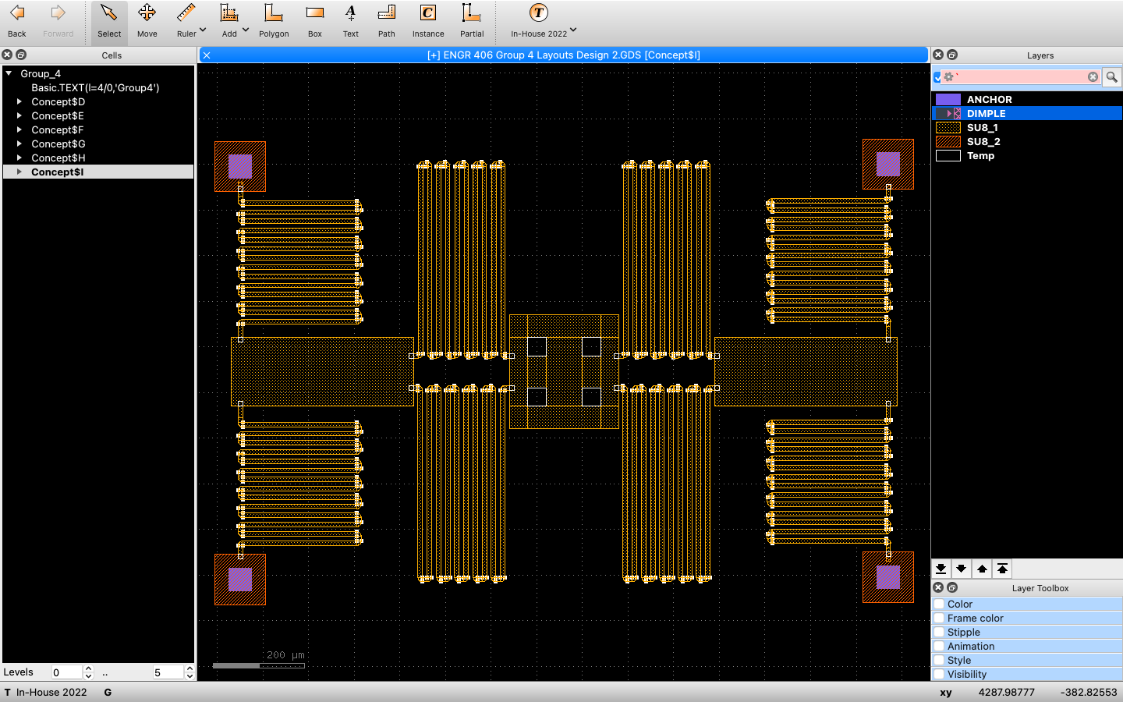

***Figure 34: Concept I Layout Without Dimples***